|  |
| --- |
| Description: E:\My Documents\Desktop\Logo_FPT_University_doc.jpg**nce :-Ministry of education and training** |
| Software Design Description |
| Teacher Left Hand |
|  |
| |  |  | | --- | --- | | **TLH Team** | | | **Group Members** | Lê Phương Giang – 60046 – GiangLP60046  Nguyễn Hồ Hải – 00268 – HaiNH00268  Nguyễn Quốc Hùng – 00267 – HungNQ00267  Tô Hồng Quân – 60061 – QuanTH60061 | | **Supervisor** | Lâm Hữu Khánh Phương | | **Ext Supervisor** |  | | **Capstone Project code** | TLH | |
| **Ho Chi Minh, 10th Feb, 2012** |

**Record of Changes**

|  |  |  |  |  |
| --- | --- | --- | --- | --- |
| Date | Change Item | Description | By | Version |
| 10/2 | Document | Create | GiangLP | 0.1 |
| 13/2 | Design overview | Add | GiangLP | 0.1 |
|  | System Architectural Design | Add | GiangLP | 0.1 |
| 14/2 | System Architectural Design | Add | GiangLP | 0.1 |
|  | Sequence Diagram | Add | GiangLP | 0.1 |
| 15/2 | Component Diagram | Add | HungNQ | 0.1 |
|  | User interface | Add | QuanTH | 0.1 |
|  | Data design | Add | HaiNH | 0.1 |
| 18/2 | CRC cards | Add | HungNQ | 0.1 |
|  | Component details | Add | HungNQ | 0.1 |
| 20/2 | Component Diagram | Modify | HungNQ | 0.2 |
|  | Component details | Add | GiangLP, QuanTH, HaiNH | 0.2 |
|  | Data design | Modify | HaiNH | 0.2 |
| 22/2 | All | Modify format | GiangLP | 0.3 |

Contents

[A. Design Overview 5](#_Toc317721124)

[B. System Architectural Design 5](#_Toc317721126)

[1. Choice of System Architecture 5](#_Toc317721127)

[2. Discussion of Alternative Designs 7](#_Toc317721128)

[2.1. Model-View-Controller 7](#_Toc317721129)

[2.2. Model-View-Presenter 7](#_Toc317721130)

[3. Description of System Interface 8](#_Toc317721131)

[C. Component Diagram 8](#_Toc317721132)

[D. Detailed Description of Components 9](#_Toc317721133)

[1. CRC Cards (Class – Responsibility – Collaborators) 9](#_Toc317721134)

[2. Component 17](#_Toc317721135)

[2.1. TLH.TeachingPlan 17](#_Toc317721136)

[2.2. TLH.KnowledgeItem 25](#_Toc317721137)

[2.3. TLH.TeachingMethod 35](#_Toc317721138)

[2.4. TLH.Utilities 43](#_Toc317721139)

[3. Sequence Diagram 49](#_Toc317721142)

**[1.2.](#_Toc317721143)****[Manage Teaching Plan](#_Toc317721143)** [49](#_Toc317721143)

**[1.3.](#_Toc317721144)****[Manage Knowledge Items](#_Toc317721144)** [51](#_Toc317721144)

**[1.4.](#_Toc317721145)****[Manage Teaching Methods](#_Toc317721145)** [53](#_Toc317721145)

[E. User Interface Design 54](#_Toc317721146)

**[1.](#_Toc317721147)****[Screen Flow](#_Toc317721147)** [54](#_Toc317721147)

**[2.](#_Toc317721148)****[Description of the User Interface](#_Toc317721148)** [55](#_Toc317721148)

**[2.1.](#_Toc317721149)****[TLH\_SCR\_100](#_Toc317721149)** [55](#_Toc317721149)

**[2.2.](#_Toc317721150)****[LH\_SCR\_200](#_Toc317721150)** [59](#_Toc317721150)

**[2.3.](#_Toc317721151)****[TLH\_SCR\_300](#_Toc317721151)** [62](#_Toc317721151)

**[2.4.](#_Toc317721152)****[TLH\_SCR\_400](#_Toc317721152)** [65](#_Toc317721152)

[F. Database Design or Data Structures 65](#_Toc317721153)

[1. Teaching Plan Structure 66](#_Toc317721154)

[2. Knowledge Item Structure 67](#_Toc317721155)

[3. Teaching Method Structure 68](#_Toc317721156)

[G. Index 70](#_Toc317721158)

# Design Overview

This document describes the detailed design of the Teaching Left Hand application. It includes the system architectural design and component details. It also describes the graphical user interface and data structures of the system.

The system architecture design describes the overview architecture of the system, the applied design pattern.

The detailed design describes the system components’ details including CRC cards, class diagram, its explanation and sequence diagrams of the main use cases.

The user interface design demonstrates the layout of the system and graphical user interface in form of screen shots. It will also list down screen controls and behaviors.

The data structure describes the structure of xml files which are used by the program.

# System Architectural Design

## Choice of System Architecture

Described as a stand-alone application with interactive and rich user experience user interfaces, Teacher Left Hand is categorized as a rich client application. Therefore, the chosen technology is **Windows Presentation Foundation (WPF)**.

View

ViewModel

Model

Commands

Data Binding

Notifications

Business Logic & Data

Presentation Logic

User Interface

Data source

**TLH Application**



User Input

Figure 1-Application Architecture

The system will use Model-View-ViewModel architectural design pattern (which is typically a WPF pattern) as the main architecture.

The main entities of the diagram above will be explained as following:

* **Model:** refers to class that represents objects in real world, or the data access layer that manipulate the data from a specific source.
* **View:**   encapsulates the presentation of the application. It refers to all elements displayed by the [GUI](http://en.wikipedia.org/wiki/GUI" \o "GUI) such as buttons, windows, graphics, and other controls, and in WPF this is typically the user control or a xaml file.
* **View Model:** is a “Model of the View”. It is an abstraction of the View that also serves in data binding between the View and the Model. It could be seen as a specialized aspect of what would be a Controller (in the [MVC](http://en.wikipedia.org/wiki/Model_View_Controller" \o "Model View Controller) pattern) that acts as a data binder/converter that changes Model information into View information and passes commands from the View into the Model. The ViewModel exposes public properties, commands, and abstractions. It is the view model that the view depends directly on, not the model.

By taking advantages of data binding capability in WPF, MVVM pattern allows the system UI and its presentation logic to be constructed separately. This shall increase system maintainability. The view-model can easily be tested by using standard unit-tests (instead of UI-testing). The view can be redesigned without changing the ViewModel, because the interface stays the same. The view-model can even be reused, in some special cases (this is usually not recommended)

## Discussion of Alternative Designs

### Model-View-Controller

Controller

View

Model

1

\*



User Input

The MVC pattern consists of one controller that directly gets all user input. Depending of the kind of input, he shows up a different view or modifies the data in the model. The model and the view are created by the controller. The view only knows about the model, but the model does not know about any other objects. The pattern was often used in good old MFC and now in ASP.NET MVC

### Model-View-Presenter

View

Presenter

Model

1entation Logic1

1



User Input

Figure 2 – MVP Architecture

In the MVP pattern the User sends the input to the view, the view forward it to presenter and presenter than modify the view or the model depending on the type of user action. The view and the presenter are tightly coupled through bi-directional relationship. The model does not know about the presenter. The view itself is passive; the presenter is the one pushes the data into the view.

## Description of System Interface

# Component Diagram

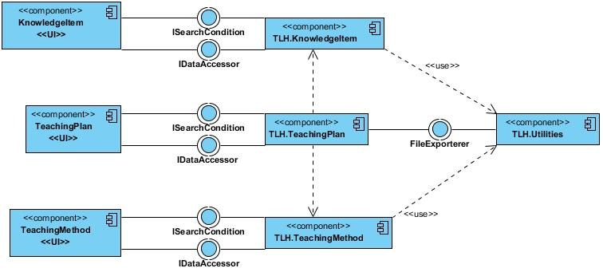

Figure 3 – System Component Diagram

**KnowledgeItem<<UI>>**: the user interface of Knowledge Item.

**TeachingPlan<<UI>>**: the user interface of Teaching Plan.

**TeachingMethod<<UI>>**: the user interface of Teaching Method.

**IDataAccessor**: the interface class includes many methods: Add, ContainsItem, Delete, GetAll, Search, and Update.

**ISearchCondition**: the interface class includes common property: SelectedClassLevel.

**TLH.KnowledgeItem**: is Knowledge Item Component

**TLH.TeachingPlan**: is Teaching Plan Component

**TLH.KnowledgeMethod**: is Knowledge Method Component

**TLH.Utilities**: is Utilities Component.

# Detailed Description of Components

## CRC Cards (Class – Responsibility – Collaborators)

|  |  |
| --- | --- |
| TeachingPlan | |
| Responsibility | **Collaborators** |
| Knows class level |  |
| Knows composed date |  |
| Knows teaching date |  |
| Knows subject |  |
| Knows topic |  |
| Know topic number |  |
| Knows session |  |
| Knows objective |  |
| Knows preparation |  |
| Knows activities |  |
| Knows note |  |

|  |  |
| --- | --- |
| TeachingPlanAccessor | |
| Responsibility | **Collaborators** |
| Handles save teaching plan |  |
| Handles get list subject |  |
| Handles load knowledge item |  |

|  |  |
| --- | --- |
| TeachingViewModel | |
| Responsibility | **Collaborators** |
| Knows activities |  |
| Knows add new activity command |  |
| Knows class level |  |
| Knows compose date |  |
| Knows error |  |
| Knows export command |  |
| Knows load command |  |
| Knows note |  |
| Knows objective |  |
| Knows open command |  |
| Knows preparation |  |
| Knows remove activity command |  |
| Knows save command |  |
| Knows session |  |
| Knows subject |  |
| Knows subject list |  |
| Knows teaching date |  |
| Knows topic |  |
| Knows topic number |  |
| Handles add new activity | TeachingPlanAccessor |
| Handles export | FileExporter |
| Handles load | TeachingPlanAccessor |
| Handles remove activity | ActivityViewModel |
| Handles save | TeachingPlanAccessor |

|  |  |
| --- | --- |
| Activity | |
| Responsibility | **Collaborators** |
| Knows content |  |
| Knows name |  |
| Knows purpose |  |
| Knows team size |  |

|  |  |
| --- | --- |
| ActivityViewModel | |
| Responsibility | **Collaborators** |
| Knows content |  |
| Knows name |  |
| Knows purpose |  |
| Knows team size |  |
| Knows isSelected |  |
| Knows remove command |  |
| Handles remove |  |
| Handles add |  |

|  |  |
| --- | --- |
| KnowledgeItem | |
| Responsibility | **Collaborators** |
| Knows id |  |
| Knows content |  |
| Knows class level |  |
| Knows subject |  |
| Knows topic |  |
| Know topic number |  |
| Knows knowledge item type |  |

|  |  |
| --- | --- |
| KnowledgeItemAccessor | |
| Responsibility | **Collaborators** |
| Handles add |  |
| Handles contain item |  |
| Handles delete |  |
| Handles get all |  |
| Handles get subject list |  |
| Handles topic list |  |
| Handles search |  |
| Handles update |  |
| Handles knowledge item accessor |  |

|  |  |
| --- | --- |
| KnowledgeItemViewModel | |
| Responsibility | **Collaborators** |
| Knows can save |  |
| Knows class level |  |
| Knows content |  |
| Knows delete command |  |
| Knows error |  |
| Knows isSelected |  |
| Knows knowledge item type |  |
| Knows save command |  |
| Knows subject |  |
| Knows subject list |  |
| Knows topic |  |
| Knows topic list |  |
| Knows topic number |  |
| Handles delete | KnowledgeItemAccessor |
| Handles save | KnowledgeItemAccessor |

|  |  |
| --- | --- |
| KnowledgeItemListViewModel | |
| Responsibility | **Collaborators** |
| Knows delete command |  |
| Knows keyword |  |
| Knows knowledge item list |  |
| Knows search condition |  |
| Knows subject list |  |
| Handles delete knowledge item | KnowledgeItemAccessor |
| Knows knowledge item accessor |  |

|  |  |
| --- | --- |
| TeachingMethod | |
| Responsibility | **Collaborators** |
| Knows id |  |
| Knows name |  |
| Knows team size |  |
| Knows tools |  |
| Knows preferred subject |  |
| Know preferred class level |  |
| Knows content |  |
| Knows note |  |
| Handles auto generate id |  |

|  |  |
| --- | --- |
| TeachingMethodAccessor | |
| Responsibility | **Collaborators** |
| Handles add |  |
| Handles contain item |  |
| Handles delete |  |
| Handles get all |  |
| Handles get subject list |  |
| Handles search | ISearchCondition |
| Handles update |  |

|  |  |
| --- | --- |
| TeachingMethodViewModel | |
| Responsibility | **Collaborators** |
| Knows can save |  |
| Knows content |  |
| Knows delete command |  |
| Knows error |  |
| Knows isSelected |  |
| Knows name |  |
| Knows note |  |
| Knows preferred class level |  |
| Knows preferred subject |  |
| Knows save command |  |
| Knows team size |  |
| Knows tools |  |
| Handles delete | TeachingMethodAccessor |
| Handles save | TeachingMethodAccessor |

|  |  |
| --- | --- |
| TeachingMethodListViewModel | |
| Responsibility | **Collaborators** |
| Knows add new teaching method command | TeachingMethodViewModel |
| Knows delete command | TeachingMethodAccessor |
| Knows search condition |  |
| Knows subject list | TeachingMethodAccessor |
| Knows teaching method list | TeachingMethodAccessor |
| Handles add new teaching method | TeachingMethodViewModel |
| Handles delete teaching method | TeachingMethodAccessor |
| Handles search | TeachingMethodAccessor |

|  |  |
| --- | --- |
| IDataAccessor | |
| Responsibility | **Collaborators** |
| Handles add |  |
| Handles contain item |  |
| Handles delete |  |
| Handles get all |  |
| Handles search | ISearchCondition |
| Handles update |  |

|  |  |
| --- | --- |
| ISearchCondition | |
| Responsibility | **Collaborators** |
| Knows selected class level |  |
| Knows keyword |  |

|  |  |
| --- | --- |
| KISearchCondition | |
| Responsibility | **Collaborators** |
| Knows max topic number |  |
| Knows min topic number |  |
| Knows selected class level |  |
| Knows subject |  |
| Handles knowledge item search condition |  |

|  |  |
| --- | --- |
| TMSearchCondition | |
| Responsibility | **Collaborators** |
| Knows preferred subject |  |
| Knows selected class level |  |
| Knows team size |  |
| Knows tools |  |

## Component

### TLH.TeachingPlan

#### Class Diagram Explanation

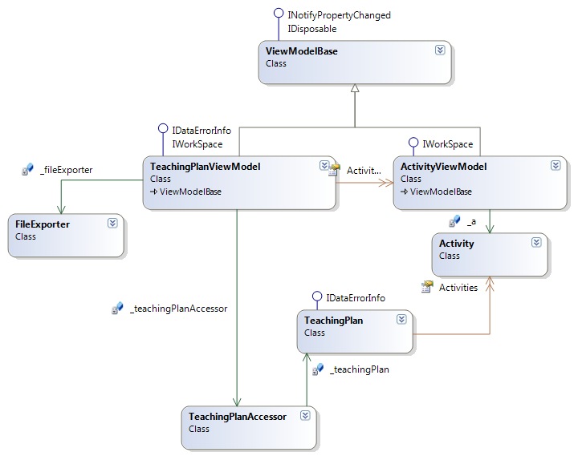

Figure 4 - Teaching Plan Class diagram

#### IDataErrorInfo interface

Get information about data error.

##### Attributes

|  |  |  |  |  |  |
| --- | --- | --- | --- | --- | --- |
| No | Attribute | Type | Default | Note | Description |
| 01 | Error | String |  | Read-only | Gets an error message indicating what is wrong with this object. |
| 02 | this | string |  | Read-only | Gets the error message for the property with the given name. |

##### Methods

N/A

#### IWorkSpace interface

##### Attributes

N/A

##### Methods

N/A

#### INotifyPropertyChanged interface

System interface

##### Attributes

N/A

##### Methods

|  |  |  |
| --- | --- | --- |
| **No** | **Method** | **Description** |
| 01 | PropertyChanged | Occurs when a property value changes. |

#### IDisposable interface

System interface

##### Attributes

N/A

##### Methods

|  |  |  |
| --- | --- | --- |
| **No** | **Method** | **Description** |
| 01 | Dispose | This method is used to dispose |

#### ViewModelBase class

##### Attributes

N/A

##### Methods

|  |  |  |
| --- | --- | --- |
| **No** | **Method** | **Description** |
| 01 | Dispose |  |
| 02 | OnPropertyChanged |  |
| 03 | PropertyChanged |  |

#### Activity class

All information of activity object.

##### Attributes

|  |  |  |  |  |  |
| --- | --- | --- | --- | --- | --- |
| **No** | **Attribute** | **Type** | **Default** | **Note** | **Description** |
| 01 | Name | String |  | Private | The activity name |
| 02 | Purpose | String |  | Private | The purpose of activity |
| 03 | Form | String |  | Private | Individual or group |
| 04 | Content | List<object> |  | Private | The content of activity |

##### Methods

N/A

#### TeachingPlan class

All information of teaching plan object.

##### Attributes

|  |  |  |  |  |  |
| --- | --- | --- | --- | --- | --- |
| **No** | **Attribute** | **Type** | **Default** | **Note** | **Description** |
| 01 | \_classLevel | Int |  | Private | The level of class. |
| 02 | \_composeDate | <Nullable>DateTime |  | Private | The date that user composes the Teaching Plan |
| 03 | \_teachingDate | <Nullable>DateTime |  | Private | The date that this Teaching Plan is used in reality. |
| 04 | \_subject | String |  | Private | The Subject to which this Teaching Plan is belonged. |
| 05 | \_topic | String |  | Private | The Topic (corresponding to Toping Number) that this Knowledge Item is most related to. |
| 06 | \_topicNo | Int |  | Private | The order of the topic is defined by user. |
| 07 | \_session | Int |  | Private | The count of the sessions (slots) of a subject in a year. |
| 08 | \_objective | String |  | Private | The objectives of the lesson. |
| 09 | \_preparation | String |  | Private | Contain all the before-class activities and equipment that teachers and students will need |
| 10 | \_activities | List<Activity> |  | Private | The combination of Teaching Method with Knowledge Item in use. |
| 11 | \_note | String |  | Private | User’s notes on the teaching plan. Can be filled on creation teaching plan or added later |

##### Methods

N/A

#### TeachingPlanAccessor class

##### Attributes

|  |  |  |  |  |  |
| --- | --- | --- | --- | --- | --- |
| **No** | **Attribute** | **Type** | **Default** | **Note** | **Description** |
| 01 | \_teachingPlan | TeachingPlan |  | Private | Teaching plan object |
| 02 | Log | ILog |  | Protected | Is used to write log file |

##### Methods

|  |  |  |
| --- | --- | --- |
| **No** | **Method** | **Description** |
| 01 | Save | Used to save teaching plan object to database |
| 02 | Load | Used to load teaching plan. |
| 03 | ExportTeachingPlan | Used to export teaching plan. |
| 04 | ParseIEumerable | Used to parse list XElement <Activity> |
| 05 | ParseActivityContent | Used to parse list XElement <Content> |

###### Save method

public static bool Save(string filePath, TeachingPlan teachingPlanObj)

Used to save teaching plan object to tlhx format

**Parameters & return**

|  |  |  |  |  |  |
| --- | --- | --- | --- | --- | --- |
| No | Parameter | Type | In/out | Default | Description |
| 01 | filePath | string | In |  | Specify the path to save file. |
| 02 | teachingPlanObj | TeachingPlan | In |  | Specify the teaching plan object |
| 03 | <return > | Boolean | Out |  | Check success or not |

###### Load method

public static TeachingPlan Load(string fileName)

Used to load teaching plan

**Parameters & return**

|  |  |  |  |  |  |
| --- | --- | --- | --- | --- | --- |
| No | Parameter | Type | In/out | Default | Description |
| 01 | fileName | string | In |  | Specify the path to load file. |
| 02 | <return> | TeachingPlan | out |  | Check success or not |

###### ExportTeachingPlan method

public static bool ExportTeachingPlan(TeachingPlan teachingPlan, string fileType, string fileName, string lang)

Used to export teaching plan

**Parameters & return**

|  |  |  |  |  |  |
| --- | --- | --- | --- | --- | --- |
| No | Parameter | Type | In/out | Default | Description |
| 01 | teachingPlan | TeachingPlan | In |  | Specific the teaching plan object |
| 02 | fileType | string | In |  | Specific the file type |
| 03 | fileName | string | In |  | Specific the file full name |
| 04 | lang | string | In |  | Specific the language |
| 05 | <return> | Bool | out |  | Check success or not |

###### ParseIENumerable method

public static List<Activity> ParseIEnumerable(IEnumerable<XElement> iEnumerable)

Used to parse list XElement<Activity>

**Parameters & return**

|  |  |  |  |  |  |
| --- | --- | --- | --- | --- | --- |
| No | Parameter | Type | In/out | Default | Description |
| 01 | iEnumerable | IEnumerable<XElement> | In |  | Specify the XElement<Activity>. |
| 02 | <return> | List<Activity> | out |  | Return list activity |

###### ParseActivityContent method

public static List<object> ParseActivityContent(IEnumerable<XElement> iEnumerable)

Used to parse list XElement<Content>

**Parameters & return**

|  |  |  |  |  |  |
| --- | --- | --- | --- | --- | --- |
| No | Parameter | Type | In/out | Default | Description |
| 01 | iEnumerable | IEnumerable<XElement> | In |  | Specify the XElement<Content>. |
| 02 | <return> | List<object> | out |  | Return list object |

#### ActivityViewModel class

##### Attributes

|  |  |  |  |  |  |
| --- | --- | --- | --- | --- | --- |
| No | Attribute | Type | Default | Note | Description |
| 01 | Content | String |  | Public | The content of activity |
| 02 | Name | string |  | Public | The name of activity |
| 03 | Purpose | String |  | Public | The purpose of activity |
| 04 | TeamSize | Int |  | Public | How many pupils in activity |
| 05 | IsSelected | Bool |  | Public |  |
| 06 | RemoveCommand | ICommand |  | Public |  |

##### Methods

|  |  |  |
| --- | --- | --- |
| No | Method | Description |
| 01 | Remove | Used to remove activity from list activity |
| 02 | Add | Used to add activity to list activity |

###### Remove method

public bool Remove()

Used to remove activity from list activity

**Parameters & return**

|  |  |  |  |  |  |
| --- | --- | --- | --- | --- | --- |
| No | Parameter | Type | In/out | Default | Description |
| 01 | <return> | Bool | out |  |  |

###### Add method

public bool Add(Activity activity)

Used to add activity to list activity

**Parameters & return**

|  |  |  |  |  |  |
| --- | --- | --- | --- | --- | --- |
| No | Parameter | Type | In/out | Default | Description |
| 01 | activity | Activity | In |  |  |
| 02 | <return> | Bool | out |  |  |

#### TeachingPlanViewModel class

##### Attributes

|  |  |  |  |  |  |
| --- | --- | --- | --- | --- | --- |
| No | Attribute | Type | Default | Note | Description |
| 01 | ClassLevel | Int |  | Public |  |
| 02 | ComposeDate | DateTime |  | Public |  |
| 03 | TeachingDate | DateTime |  | Public |  |
| 04 | Note | String |  | Public |  |
| 05 | Objective | String |  | Public |  |
| 06 | Preparation | String |  | Public |  |
| 07 | Seesion | Int |  | Public |  |
| 08 | Subject | String |  | Public |  |
| 09 | Topic | String |  | Public |  |
| 10 | TopicNo | Int |  | Public |  |
| 11 | SubjectList | ObservableCollection<string> |  | Public |  |
| 12 | SaveCommand | ICommand |  | Public |  |
| 13 | ExportCommand | ICommand |  | Public |  |
| 14 | Activities | ObservableCollection<ActivityViewModel> |  | Public |  |
| 15 | OpenCommand | ICommand |  | Public |  |
| 16 | RemoveActivityCommand | ICommand |  | Public |  |
| 17 | AddnewActivityCommand | ICommand |  | Public |  |
| 18 | LoadCommand | ICommand |  | Public |  |

##### Methods

|  |  |  |
| --- | --- | --- |
| No | Method | Description |
| 01 | AddNewActivity | Used to add new activity |
| 02 | Export | Used to export teaching plan |
| 03 | RemoveActivity | Used to remove activity |
| 04 | Save | Used to save teaching plan |
| 05 | Load | Used to load teaching plan |

AddNewActivity method

public bool AddNewActivity()

Used to add new activity

**Parameters & return**

|  |  |  |  |  |  |
| --- | --- | --- | --- | --- | --- |
| No | Parameter | Type | In/out | Default | Description |
| 01 | <return> | Bool | out |  |  |

Export method

public bool Export()

Used to export teaching plan

**Parameters & return**

|  |  |  |  |  |  |
| --- | --- | --- | --- | --- | --- |
| No | Parameter | Type | In/out | Default | Description |
| 01 | <return> | Bool | out |  |  |

RemoveActivity method

public void RemoveActivity()

Used to remove activity

**Parameters & return**

|  |  |  |  |  |  |
| --- | --- | --- | --- | --- | --- |
| No | Parameter | Type | In/out | Default | Description |
| 01 | <return> | Bool | out |  |  |

Save method

public bool Save()

Used to save teaching plan

**Parameters & return**

|  |  |  |  |  |  |
| --- | --- | --- | --- | --- | --- |
| No | Parameter | Type | In/out | Default | Description |
| 01 | <return> | Bool | out |  |  |

Load method

public bool Load()

Used to load teaching plan

**Parameters & return**

|  |  |  |  |  |  |
| --- | --- | --- | --- | --- | --- |
| No | Parameter | Type | In/out | Default | Description |
| 01 | <return> | Bool | out |  |  |

### TLH.KnowledgeItem

#### Class Diagram Explanation

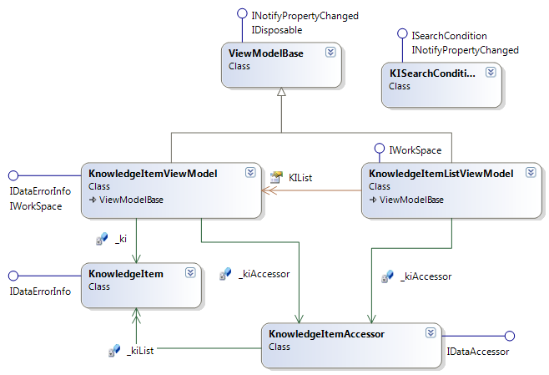

Figure 5 - Knowledge Item Class Diagram

#### Knowledge Item class

This class is the model class of Knowledge Item object.

* + - * 1. Attributes

|  |  |  |  |  |  |
| --- | --- | --- | --- | --- | --- |
| No | Attribute | Type | Default | Note | Description |
| 01 | ClassLevel | int |  |  |  |
| 02 | Content | string |  |  |  |
| 03 | Error | string |  |  |  |
| 04 | ID | string |  |  |  |
| 05 | KIType | string |  |  |  |
| 07 | Subject | string |  |  |  |
| 08 | this | string |  |  |  |
| 09 | Topic | string |  |  |  |
| 10 | TopicNo | int |  |  |  |

* + - * 1. Methods

|  |  |  |
| --- | --- | --- |
| No | Method | Description |
| 01 | KnowledgeItem | Knowledge Item's Constructor |
| 02 | ToString | Used to return this KI represented string. |

*KnowledgeItem method*

public KnowledgeItem(string content = null, int classLevel = 1, string subject = null,

string topic = null,int topicNo = 1, string kitype = Practical){}

Knowledge Item's Constructor

**Parameters & return**

|  |  |  |  |  |  |
| --- | --- | --- | --- | --- | --- |
| No | Parameter | Type | In/out | Default | Description |
| 01 | content | string | In | null | Content of the KI |
| 02 | classLevel | int | In | 1 | Class Level : from 1 - 5 |
| 03 | subject | string | In | null | Subject : fixed from a pre-defined list |
| 04 | topic | string | In | null | Topic : fixed from a pre-defined list |
| 05 | topicNo | int | In | 1 |  |
| 06 | kitype | string | In | Practical |  |
| 07 | return | KnowledgeItem | Out | null |  |

###### ToString method

public override string ToString(){}

Used to return this KI represented string.

**Parameters & return**

|  |  |  |  |  |  |
| --- | --- | --- | --- | --- | --- |
| No | Parameter | Type | In/out | Default | Description |
| 03 | return | string | Out | null |  |

#### KnowledgeItemViewModel class

This class is the View Model of a single Knowledge Item.

* + - * 1. Attributes

|  |  |  |  |  |  |
| --- | --- | --- | --- | --- | --- |
| No | Attribute | Type | Default | Note | Description |
| 01 | CanSace | bool |  |  |  |
| 02 | ClassLevel | int |  |  |  |
| 03 | Content | string |  |  |  |
| 04 | DeleteCommand | ICommand |  |  |  |
| 05 | Error | string |  |  |  |
| 06 | IsSelected | bool |  |  |  |
| 07 | KIType | string |  |  |  |
| 08 | SaveCommand | ICommand |  |  |  |
| 09 | Subject | string |  |  |  |
| 10 | SubjectList | int |  |  |  |
| 11 | this | string |  |  |  |
| 12 | Topic | string |  |  |  |
| 13 | TopicList | int |  |  |  |
| 14 | TopicNo | int |  |  |  |

* + - * 1. Methods

|  |  |  |
| --- | --- | --- |
| No | Method | Description |
| 01 | Delete | Used to delete KI from the database. |
| 02 | Save | Used to save KI to the database. |

*Delete method*

public bool Delete(){}

Used to delete KI from the database.

**Parameters & return**

|  |  |  |  |  |  |
| --- | --- | --- | --- | --- | --- |
| No | Parameter | Type | In/out | Default | Description |
| 01 | obj | object | In |  |  |
| 02 | return | bool | Out |  |  |

###### Save method

public bool Save(object obj){}

Used to save KI to the database.

**Parameters & return**

|  |  |  |  |  |  |
| --- | --- | --- | --- | --- | --- |
| No | Parameter | Type | In/out | Default | Description |
| 01 | obj | object | In |  |  |
| 02 | return | bool | out |  |  |

#### KnowledgeItemListViewModel class

This class is the View Model of a collection of Knowledge Items.

* + - * 1. Attributes

|  |  |  |  |  |  |
| --- | --- | --- | --- | --- | --- |
| No | Attribute | Type | Default | Note | Description |
| 01 | DeleteCommand | ICommand |  |  |  |
| 02 | Keyword | string |  |  |  |
| 03 | KIList | ObservableCollection<KnowledgeItem> |  |  |  |
| 04 | SearchCommand | ICommand |  |  |  |
| 05 | SearchCondition | KISearchCondition |  |  |  |
| 06 | SubjectList | int |  |  |  |

* + - * 1. Methods

|  |  |  |
| --- | --- | --- |
| **No** | **Method** | **Description** |
| 01 | DeleteKI | Used to delete KI from a list |
| 02 | SearchKI | Used to search KI. |

*DeleteKI method*

public bool DeleteKI(){}

Used to delete KI from a list

**Parameters & return**

|  |  |  |  |  |  |
| --- | --- | --- | --- | --- | --- |
| No | Parameter | Type | In/out | Default | Description |
| 01 | return | bool | Out |  | Delete KI successful identification flag. |

###### SearchKI method

public ObservableCollection<KnowledgeItem> SearchKI(){}

Used to search KI.

**Parameters & return**

|  |  |  |  |  |  |
| --- | --- | --- | --- | --- | --- |
| No | Parameter | Type | In/out | Default | Description |
| 01 | return | ObservableCollection<KnowledgeItem> | Out |  | Search KI results. |

#### KnowledgeItemAccessor class

This class is used for accessing KIs.

* + - * 1. Attributes

|  |  |  |  |  |  |
| --- | --- | --- | --- | --- | --- |
| No | Attribute | Type | Default | Note | Description |
| 01 | KIList | List<KnowledgeItem> | N/A |  |  |
|  |  |  |  |  |  |

* + - * 1. Methods

|  |  |  |
| --- | --- | --- |
| No | Method | Description |
| 01 | Add | Used to add KI to a KI collection. |
| 02 | ContainsItem | Used to check if the inputted KI is contains in the collection |
| 03 | Delete | Used to delete KI from the KI collection |
| 04 | GetAll | Used to get all KI from the collection |
| 05 | GetSubjectList | Used to get all the subject list of KI collection |
| 06 | GetTopicList | Used to get the topic list of KI collection |
| 07 | KnowledgeItemAccessor | Constructor |
| 08 | Search | Used to search KIs. |
| 09 | Update | Used to update a KI. |

*Add method*

public bool Add(object obj){}

Used to add KI to a KI collection.

**Parameters & return**

|  |  |  |  |  |  |
| --- | --- | --- | --- | --- | --- |
| No | Parameter | Type | In/out | Default | Description |
| 01 | obj | object | In |  |  |
| 02 | return | bool | Out |  |  |

###### ContentItem method

public bool ContainsItem(object obj){}

Used to check if the inputted KI is contains in the collection

**Parameters & return**

|  |  |  |  |  |  |
| --- | --- | --- | --- | --- | --- |
| No | Parameter | Type | In/out | Default | Description |
| 01 | obj | object | In |  |  |
| 02 | return | bool | Out |  |  |

###### Delete method

public bool Delete(object obj){}

Used to delete KI from the KI collection

**Parameters & return**

|  |  |  |  |  |  |
| --- | --- | --- | --- | --- | --- |
| No | Parameter | Type | In/out | Default | Description |
| 01 | obj | object | In |  |  |
| 02 | return | bool | Out |  |  |

###### GetAll method

public System.Collections.ObjectModel.ObservableCollection<object> GetAll(){}

Used to get all KI from the collection

**Parameters & return**

|  |  |  |  |  |  |
| --- | --- | --- | --- | --- | --- |
| No | Parameter | Type | In/out | Default | Description |
| 01 | return | ObservableCollection<object> | Out |  |  |

###### GetSubjectList method

public List<string> GetSubjectList(){}

Used to get all the subject list of KI collection

**Parameters & return**

|  |  |  |  |  |  |
| --- | --- | --- | --- | --- | --- |
| No | Parameter | Type | In/out | Default | Description |
| 01 | return | List<string> | Out |  |  |

###### GetTopicList method

public List<string> GetTopicList(){}

Used to get the topic list of KI collection

**Parameters & return**

|  |  |  |  |  |  |
| --- | --- | --- | --- | --- | --- |
| No | Parameter | Type | In/out | Default | Description |
| 01 | return | List<string> | Out |  |  |

###### KnowledgeItemAccessor method

public KnowledgeItemAccessor(){}

Constructor

|  |  |  |  |  |  |
| --- | --- | --- | --- | --- | --- |
| No | Parameter | Type | In/out | Default | Description |
|  |  |  |  |  |  |

###### Search method

public System.Collections.ObjectModel.ObservableCollection<object> Search(ISearchCondition searchCondition){}

Used to search for KIs.

**Parameters & return**

|  |  |  |  |  |  |
| --- | --- | --- | --- | --- | --- |
| No | Parameter | Type | In/out | Default | Description |
| 01 | searchCondition | ISearchCondition | In |  |  |
| 02 | return | ObservableCollection<object> | Out |  |  |

###### Update method

public bool Update(object obj){}

Used to update KI.

**Parameters & return**

|  |  |  |  |  |  |
| --- | --- | --- | --- | --- | --- |
| No | Parameter | Type | In/out | Default | Description |
| 01 | obj | object | In |  |  |
| 02 | return | bool | Out |  |  |

#### KISearchCondition class

This class contains KI Search Conditions.

* + - * 1. Attributes

|  |  |  |  |  |  |
| --- | --- | --- | --- | --- | --- |
| No | Attribute | Type | Default | Note | Description |
| 01 | MaxTopicNo | int |  |  |  |
| 02 | MinTopicNo | int |  |  |  |
| 03 | SelectedClassLevel | int |  |  |  |
| 04 | Subject | string |  |  |  |

* + - * 1. Methods

|  |  |  |
| --- | --- | --- |
| No | Method | Description |
| 01 | KISearchCondition | Constructor |

###### KISearchCondition method

public KISearchCondition(){}

This is the KISearchCondition 's Constructor **Parameters & return**

**Parameters & return**

|  |  |  |  |  |  |
| --- | --- | --- | --- | --- | --- |
| No | Parameter | Type | In/out | Default | Description |
|  |  |  |  |  |  |

### TLH.TeachingMethod

#### Class Diagram Explanation

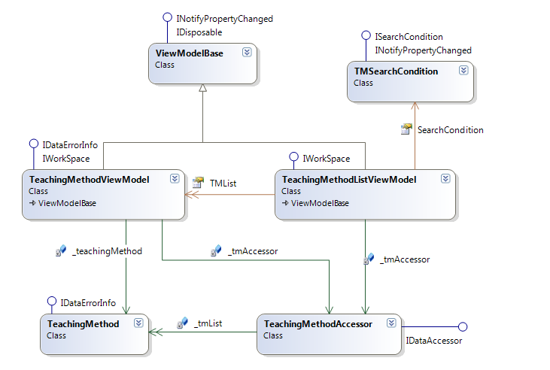

Figure 6 - Teaching Method Class Diagram

#### TMSearchCondition Class

##### Attributes

|  |  |  |  |  |  |
| --- | --- | --- | --- | --- | --- |
| No | Attribute | Type | Default | Note | Description |
| 1 | PreferredSubject | List<string> |  | public | Preferred subjects to search |
| 2 | SelectedClassLevel | int |  | public | Class level to search |
| 3 | TeamSize | string |  | public | Team size to search |
| 4 | Tools | string |  | public | tools |

##### Methods

N/A

#### TeachingMethodViewModel class

##### **Attributes**

|  |  |  |  |  |  |
| --- | --- | --- | --- | --- | --- |
| No | Attribute | Type | Default | Note | Description |
| 1 | CanSave | bool |  | Public | Return whether this teaching method is valid |
| 2 | Content | string |  | Public | Content of the teaching method |
| 3 | DeleteCommand | ICommand |  | Public | Delete command, bind to the delete button or context menu |
| 4 | Error | string |  | Public | Gets an error message indicating what is wrong with this object |
| 5 | IsSelected | bool |  | Public | Whether this teaching methods is selected from the search view |
| 6 | Name | string |  | Public | Teaching method name |
| 7 | Note | string |  | Public | Teaching method note |
| 8 | PreferredClassLevel | int |  | Public | Preferred class level for this teaching method |
| 9 | PreferredSubject | String |  | Public | Preferred subject for this teaching method |
| 10 | SaveCommand | ICommand |  | Public | Save Command, bind to the Save button or context menu |
| 11 | TeamSize | String |  | Public | Teaching method’s team size |
| 12 | Tools | String |  | Public | Necessary tools for this teaching method |
| 13 | \_teachingMethod | TeachingMethod |  | Private | An object represent the working teaching method |
| 14 | \_tmAccessor | IDataAccessor |  | Private | An object represent teaching method accessor to handle CRUD actions |

##### **Methods**

|  |  |  |
| --- | --- | --- |
| No | Method | Description |
| 1 | Delete | Delete the current teaching method |
| 2 | Save | Add the current teaching method to the database |

###### Delete method

Public bool Delete()

Delete the current teaching method

**Parameters & return**

|  |  |  |  |  |  |
| --- | --- | --- | --- | --- | --- |
| No | Parameter | Type | In/out | Default | Description |
| 1 | Return | Bool |  |  | Return whether delete action finished successfully |

**Implementation**

Call the \_tmAccessor to delete the current \_teachingMethod

Return whether this action is successfully done.

###### Save method

Public bool Save()

Save the current teaching method

**Parameters & return**

|  |  |  |  |  |  |
| --- | --- | --- | --- | --- | --- |
| No | Parameter | Type | In/out | Default | Description |
| 1 | Return | Bool |  |  | Return whether save action finished successfully |

**Implementation**

Call the \_tmAccessor to save the current \_teachingMethod

Return whether this action is successfully done.

#### TeachingMethodListViewModel class

##### Attributes

|  |  |  |  |  |  |
| --- | --- | --- | --- | --- | --- |
| No | Attribute | Type | Default | Note | Description |
| 1 | DeleteCommand | ICommand |  | Public | Delete Command, bind to delete button or context menu |
| 2 | SearchCommand | ICommand |  | public | Search command, bind to search button |
| 3 | SearchCondition | TMSearchCondition |  | public | User inputted Search condition |
| 4 | SubjectList | ObservableCollection<string> |  | public | List of existed subject in the database, bind to the subject list in the view |
| 5 | TMList | ObservableCollection<TeachingMethodViewModel> |  | public | List of teaching method, bind to display the search results |
| 6 | \_tmAccessor | TeachingMethodAccessor |  | private | A data accessor to work with the database |

##### Methods

|  |  |  |
| --- | --- | --- |
| No | Method | Description |
| 1 | Delete | Delete a selected teaching method from the database |
| 2 | Search | Search teaching method based on provided condition |

###### Delete method

Public bool Delete()

Delete a selected teaching method from the database

**Parameters & return**

|  |  |  |  |  |  |
| --- | --- | --- | --- | --- | --- |
| No | Parameter | Type | In/out | Default | Description |
| 1 | Return | bool |  |  | Return whether save action finished successfully |

**Implementation**

Call the \_tmAccessor to delete the selected \_teachingMethod

Return whether this action is successfully done.

###### Search method

Public ObservableCollection<IKnowledge> Search(ISearchCondition searchCondition)

Search the database and return a list of teaching method that match the search condition

**Parameters & return**

|  |  |  |  |  |  |
| --- | --- | --- | --- | --- | --- |
| No | Parameter | Type | In/out | Default | Description |
| 1 | searchCondition | ISearchCondition | in |  | Search condition |
| 2 | Return | ObservableCollection<IKnowledge> |  |  | Return a collection of search results |

Implementation

Receive a seach condition

Call the \_tmAccessor to search with the provided condition

Return a collection of searched results.

#### TeachingMethod class

##### Attributes

|  |  |  |  |  |  |
| --- | --- | --- | --- | --- | --- |
| No | Attribute | Type | Default | Note | Description |
| 1 | Content | string |  | Public | Get or set Teaching method content |
| 2 | Error | string |  | Public | Gets an error message indicating what is wrong with this object |
| 3 | ID | string |  | public | Get Teaching method ID |
| 4 | Name | string |  | public | Get or set teaching method name |
| 5 | Note | string |  | Public | Get or set teaching method note |
| 6 | PreferredClassLevel | int |  | Public | Get or set teaching method preferred class level |
| 7 | PreferredSubject | String |  | Public | Get or set teaching method preferred subject |
| 8 | TeamSize | string |  | public | Get or set teaching method team size |
| 9 | Tools | string |  | Public | Get or set teaching method tools |

##### Methods

N/A

#### TeachingMethodAccessor class

##### Attributes

N/A

##### Methods

|  |  |  |
| --- | --- | --- |
| No | Method | Description |
| 1 | Add | Add new teaching method to the database |
| 2 | ContainsItem | Check if the item already existed |
| 3 | Delete | Delete a teaching method |
| 4 | GetAll | Get all existed teaching method |
| 5 | GetSubjectList | Get all subjects in the database |
| 6 | Search | Search the database to find teaching methods match with a specific condition |
| 7 | Update | Update a teaching method |

###### Add method

Public bool Add(IKnowledge item)

**Add a new teaching method to the database**

Parameters & return

|  |  |  |  |  |  |
| --- | --- | --- | --- | --- | --- |
| No | Parameter | Type | In/out | Default | Description |
| 1 | item | IKnowledge | in |  | The teaching method to add |
| 2 | Return | Bool |  |  | Return whether add action is successful |

Implementation

Receive a teaching method

Add to the database

Return if the action is done successfully

###### ContainsItem method

Public bool ContainsItem(IKnowledge item)

Check if teaching method already existed in the database

Parameters & return

|  |  |  |  |  |  |
| --- | --- | --- | --- | --- | --- |
| No | Parameter | Type | In/out | Default | Description |
| 1 | item | IKnowledge | in |  | The teaching method to check |
| 2 | Return | Bool |  |  | Return whether the method already existed |

**Implementation**

Receive a teaching method

Check the database

Return if the teaching method already existed

###### Delete Method

Public bool Delete(IKnowledge item)

Delete a teaching method from the database

Parameters & return

|  |  |  |  |  |  |
| --- | --- | --- | --- | --- | --- |
| No | Parameter | Type | In/out | Default | Description |
| 1 | item | IKnowledge | in |  | The teaching method to add |
| 2 | Return | Bool |  |  | Return whether add action is successful |

Implementation

Receive a teaching method

Add to the database

Return if the action is done successfully

###### GetAll Method

Public ObservableCollection<Iknowledge> GetAll

Get All teaching methods from the database

Parameters & return

|  |  |  |  |  |  |
| --- | --- | --- | --- | --- | --- |
| No | Parameter | Type | In/out | Default | Description |
| 1 | Return | O |  |  | Return a collection of all teaching methods |

###### Search Method

Public ObservableCollection<IKnowledge> Search(ISearchCondition searchCondition)

Search Teaching Method that match user conditions

Parameters & return

|  |  |  |  |  |  |
| --- | --- | --- | --- | --- | --- |
| No | Parameter | Type | In/out | Default | Description |
| 1 | searchCondition | ISearchCondition | In |  | Search Condition |
| 2 | Return |  |  |  | Return a collection of search result |

Implementation

Receive a search condition

Search in the database

Return search result collection

###### Update Method

Public bool Update(IKnowledge item)

Update a teaching method

Parameters & return

|  |  |  |  |  |  |
| --- | --- | --- | --- | --- | --- |
| No | Parameter | Type | In/out | Default | Description |
| 1 | item | IKnowledge | in |  | The teaching method to update |
| 2 | Return |  |  |  | Return whether add action is successful |

Implementation

Receive a teaching method

Update to the database

Return if the action is done successfully

### TLH.Utilities

#### Class Diagram Explanation

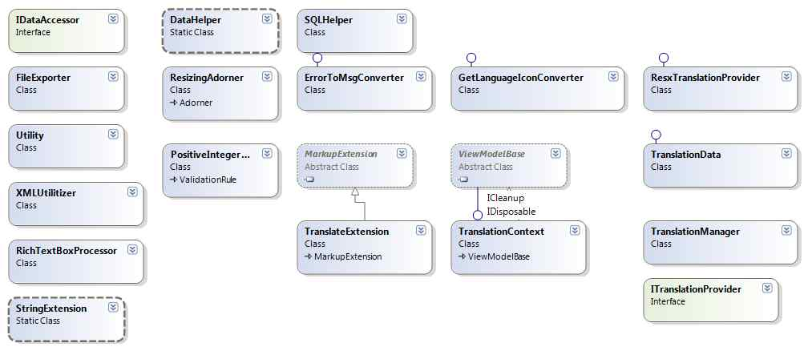

#### IDataAccessor interface

##### **Attributes**

N/A

##### **Methods**

|  |  |  |
| --- | --- | --- |
| No | Method | Description |
| 01 | Search | Search according condition parameter. The condition parameter type is derived from ISearchCondition interface. This method return an ObservableCollection<object> |
| 02 | GetAll | Get all items from database. This method return an ObservableCollection<object> |
| 03 | Add | Add item to database. This method return True if add successfully, False if otherwise |
| 04 | Delete | Delete item from database. This method return True if delete successfully, False if otherwise |
| 05 | Update | Update item into database. This method return True if update successfully, False if otherwise |
| 06 | ContainsItem | Check if item is in database. This method return True if database contains the item, False if otherwise |

###### Search method

* **Method Declaration:**

ObservableCollection<IData> Search(ISearchCondition searchCondition);

* **Method Description:**

Search according condition parameter. The condition parameter type is derived from ISearchCondition interface. This method returns an ObservableCollection<object>

* **Parameters & return**

|  |  |  |  |  |  |
| --- | --- | --- | --- | --- | --- |
| No | Parameter | Type | In/out | Default | Description |
| 01 | searchCondition | ISearchCondition | In |  | Describe the condition for searching |
| 02 | <return > | ObservableCollection<object> | Out |  | The returned result of method |

###### GetAll method

* ***Method Declaration***:

ObservableCollection<IData> GetAll();

* **Method Description:**

Get all items from database. This method return an ObservableCollection<object>

* **Parameters & return**

|  |  |  |  |  |  |
| --- | --- | --- | --- | --- | --- |
| No | Parameter | Type | In/out | Default | Description |
| 1 | <return > | ObservableCollection<object> | Out |  | The returned result of method |

###### Add method

* ***Method Declaration:***

bool Add(IData item);

* ***Method Description:***

Add item to database. This method return True if add successfully, False if otherwise

* **Parameters & return**

|  |  |  |  |  |  |
| --- | --- | --- | --- | --- | --- |
| No | Parameter | Type | In/out | Default | Description |
| 01 | obj | Object | In |  | The parameter used to add to database |
| 02 | <return > | bool | Out |  | The returned result of method |

###### Delete method

* ***Method Declaration:***

bool Delete(IData item);

* ***Method Description:***

Delete item from database. This method return True if delete successfully, False if otherwise

* **Parameters & return**

|  |  |  |  |  |  |
| --- | --- | --- | --- | --- | --- |
| No | Parameter | Type | In/out | Default | Description |
| 01 | obj | Object | In |  | The parameter used to delete from database |
| 02 | <return > | bool | Out |  | The returned result of method |

###### Update method

* ***Method Declaration:***

bool Update(IData item);

* ***Method Description:***

Update item into database. This method return True if update successfully, False if otherwise

* ***Parameters & return***

|  |  |  |  |  |  |
| --- | --- | --- | --- | --- | --- |
| No | Parameter | Type | In/out | Default | Description |
| 01 | Obj | Object | In |  | The item that will be update in database |
| 02 | <return > | bool | Out |  | The returned result of method |

###### ContainsItem method

* ***Method Declaration:***

bool ContainsItem(IData item);

* ***Method Description:***

Check if item is in database. This method return True if database contains the item, False if otherwise

* ***Parameters & return***

|  |  |  |  |  |  |
| --- | --- | --- | --- | --- | --- |
| No | Parameter | Type | In/out | Default | Description |
| 01 | Obj | Object | In |  | The item used to check where it is in database |
| 02 | <return > | bool | Out |  | The returned result of method |

#### RichTextBoxProcessor class

##### Attributes

|  |  |  |  |  |  |
| --- | --- | --- | --- | --- | --- |
| **No** | **Attribute** | **Type** | **Default** | **Note** | **Description** |
| 01 | Log | ILog | Protected | static | Used to write log. |
| 02 | flowDocument | FlowDocument | Public | static |  |
| 03 | bpara | Paragraph | Public | Static |  |

##### Methods

|  |  |  |
| --- | --- | --- |
| No | Method | Description |
| 01 | ConvertToString | Convert the content of rich text box into string |
| 02 | ConvertToFlowDocument | Convert the stream to FlowDocument |
| 03 | GetInLineText | Used to get content inline the richtextbox |
| 04 | RecursiveGetInlineText | Help to get inline richtextbox |

###### ConvertToString method

* ***Method Declaration:***

public static string ConvertToString(RichTextBox richTextBox)

* ***Method Description:***

Convert the content of rich text box into string

* ***Parameters & return***

|  |  |  |  |  |  |
| --- | --- | --- | --- | --- | --- |
| No | Parameter | Type | In/out | Default | Description |
| 01 | richTextBox | RichTextBox | In |  | The parameter used to convert to string |
| 02 | <return > | String | Out |  | The returned result of method |

###### ConvertToFlowDocument method

* ***Method Declaration:***

public static FlowDocument ConvertToFlowDocument(string strStream)

* ***Method Description:***

Convert the stream to FlowDocument

* **Parameters & return**

|  |  |  |  |  |  |
| --- | --- | --- | --- | --- | --- |
| No | Parameter | Type | In/out | Default | Description |
| 01 | strStream | string | In |  | The parameter used to convert to FlowDocument |
| 02 | <return > | FlowDocument | Out |  | The returned result of method |

###### GetInlineText method

* ***Method Declaration:***

public static FlowDocument GetInlineText(RichTextBox myRichTextBox, string typeAction)

* ***Method Description:***

Convert the content of rich text box into flowdocument

* ***Parameters & return***

|  |  |  |  |  |  |
| --- | --- | --- | --- | --- | --- |
| No | Parameter | Type | In/out | Default | Description |
| 01 | myRichTextBox | RichTextBox | In |  | The parameter used to convert to flowdocument |
| 02 | typeAction | string | In |  | Save, load or export |
| 03 | <return > | FlowDocument | Out |  | The returned result of method |

###### RecursiveGetInlineText method

* ***Method Declaration:***

public static void RecursiveGetInlineText(RichTextBox myRichTextBox, string typeAction)

* ***Method Description:***
* **Parameters & return**

|  |  |  |  |  |  |
| --- | --- | --- | --- | --- | --- |
| No | Parameter | Type | In/out | Default | Description |
| 01 | myRichTextBox | RichTextBox | In |  | The parameter used to convert to flowdocument |
| 02 | typeAction | string | In |  | Save, load or export |

#### XMLUtilitizer class

##### Attributes

|  |  |  |  |  |  |
| --- | --- | --- | --- | --- | --- |
| No | Attribute | Type | Default | Note | Description |
| 01 | KIPath | String |  | const | Contain the path of KnowledgeItem XML |
| 02 | TMPath | string |  | Const | Contain the path of TeachingMethod XML |

##### Methods

|  |  |  |
| --- | --- | --- |
| No | Method | Description |
| 01 | Load | Load the XElement from database |
| 02 | GetFilePath | Get the path of the file |
| 03 | ConvertFlowDocumentToSUBStringFormat | Convert flow document to string format |
| 04 | TransformImagesTo64 | Transform image in flow document to base 64 |
| 05 | TransformImagesTo64 | Transform image in inline to base 64 |
| 06 | TransformImagesTo64 | Transform image in block to base 64 |
| 07 | Transform64ToImage | Transform image base 64 in flow document to image |
| 08 | Transform64ToImage | Transform image base 64 in inline to image |
| 09 | Transform64ToImage | Transform image base 64 in block to image |
| 10 | TransformImageTo64String | Transform image to string base 64 |
| 11 | ToByteArray | Convert flow document to byte array |
| 12 | BytesToBase64 | Convert byte data base 64 to string |
| 13 | Base64ToBytes | Convert string base 64 to byte base 64 |
| 14 | LoadXAMLPackage | Load array byte to flow document |

###### Load method

* ***Method Declaration:***

public static XElement Load(string dbName)

* ***Method Description:***

Load the XElement from database

* ***Parameters & return***

|  |  |  |  |  |  |
| --- | --- | --- | --- | --- | --- |
| No | Parameter | Type | In/out | Default | Description |
| 01 | dbName | string | In |  | The parameter contain the name of database |
| 02 | <return > | XElement | Out |  | The returned result of method |

###### **GetFilePath method**

* ***Method Declaration:***

public static string GetFilePath(string key)

* **Method Description**:

Get the path of the file

* **Parameters & return**

|  |  |  |  |  |  |
| --- | --- | --- | --- | --- | --- |
| No | Parameter | Type | In/out | Default | Description |
| 01 | Key | string | In |  | The parameter |
| 02 | <return > | string | Out |  | The returned result of method |

###### ConvertFlowDocumentToSUBStringFormat method

* ***Method Declaration:***

public static string ConvertFlowDocumentToSUBStringFormat(FlowDocument flowDocument)

* **Method Description**:

Convert flow document to string format

* **Parameters & return**

|  |  |  |  |  |  |
| --- | --- | --- | --- | --- | --- |
| No | Parameter | Type | In/out | Default | Description |
| 01 | flowDocument | FlowDocument | In |  | The parameter |
| 02 | <return > | string | Out |  | The returned result of method |

###### TransformImagesTo64 method

* ***Method Declaration:***

public static void TransformImagesTo64(FlowDocument flowDocument)

* **Method Description**:

Transform image in flow document to base 64

* **Parameters & return**

|  |  |  |  |  |  |
| --- | --- | --- | --- | --- | --- |
| No | Parameter | Type | In/out | Default | Description |
| 01 | flowDocument | FlowDocument | In |  | The parameter |

###### TransformImagesTo64 method

* ***Method Declaration:***

public static void TransformImagesTo64(Inline i)

* **Method Description**:

Transform image in inline to base 64

* **Parameters & return**

|  |  |  |  |  |  |
| --- | --- | --- | --- | --- | --- |
| No | Parameter | Type | In/out | Default | Description |
| 01 | i | Inline | In |  | The parameter |

###### TransformImagesTo64 method

* ***Method Declaration:***

public static void TransformImagesTo64(Block b)

* **Method Description**:

Transform image in block to base 64

* **Parameters & return**

|  |  |  |  |  |  |
| --- | --- | --- | --- | --- | --- |
| No | Parameter | Type | In/out | Default | Description |
| 01 | b | Block | In |  | The parameter |

###### Transform64ToImage method

* ***Method Declaration:***

public static FlowDocument Transform64ToImage(FlowDocument flowDocument)

* **Method Description**:

Transform image base 64 in flow document to image

* **Parameters & return**

|  |  |  |  |  |  |
| --- | --- | --- | --- | --- | --- |
| No | Parameter | Type | In/out | Default | Description |
| 01 | flowDocument | FlowDocument | In |  | The parameter |
| 02 | <return> | FlowDocument | Out |  | The returned result of method |

###### Transform64ToImage method

* ***Method Declaration:***

public static void Transform64ToImage(Inline inline)

* **Method Description**:

Transform image base 64 in inline to image

* **Parameters & return**

|  |  |  |  |  |  |
| --- | --- | --- | --- | --- | --- |
| No | Parameter | Type | In/out | Default | Description |
| 01 | Inline | Inline | In |  | The parameter |

###### Transform64ToImage method

* ***Method Declaration:***

public static void Transform64ToImage(Inline inline)

* **Method Description**:

Transform image base 64 in block to image

* **Parameters & return**

|  |  |  |  |  |  |
| --- | --- | --- | --- | --- | --- |
| No | Parameter | Type | In/out | Default | Description |
| 01 | block | Block | In |  | The parameter |

###### TransformImageTo64String method

* ***Method Declaration:***

public static string TransformImageTo64String(FlowDocument flowDocument)

* **Method Description**:

Transform image to string base 64

* **Parameters & return**

|  |  |  |  |  |  |
| --- | --- | --- | --- | --- | --- |
| No | Parameter | Type | In/out | Default | Description |
| 01 | flowDocument | FlowDocument | In |  | The parameter |
| 02 | <return> | String | Out |  | The returned result of method |

###### ToByteArray method

* ***Method Declaration:***

public static byte[] ToByteArray(FlowDocument flowDocument)

* **Method Description**:

Convert flow document to byte array

* **Parameters & return**

|  |  |  |  |  |  |
| --- | --- | --- | --- | --- | --- |
| No | Parameter | Type | In/out | Default | Description |
| 01 | flowDocument | FlowDocument | In |  | The parameter |
| 02 | <return> | Byte[] | Out |  | The returned result of method |

###### BytesToBase64 method

* ***Method Declaration:***

public static string BytesToBase64(byte[] byteData)

* **Method Description**:

Convert byte data base 64 to string

* **Parameters & return**

|  |  |  |  |  |  |
| --- | --- | --- | --- | --- | --- |
| No | Parameter | Type | In/out | Default | Description |
| 01 | byteData | Byte[] | In |  | The parameter |
| 02 | <return> | String | Out |  | The returned result of method |

###### Base64ToBytes method

* ***Method Declaration:***

public static byte[] Base64ToBytes(string sText\_Base64)

* **Method Description**:

Convert string base 64 to byte base 64

* **Parameters & return**

|  |  |  |  |  |  |
| --- | --- | --- | --- | --- | --- |
| No | Parameter | Type | In/out | Default | Description |
| 01 | sText\_Base64 | String | In |  | The parameter |
| 02 | <return> | Byte[] | Out |  | The returned result of method |

###### LoadXAMLPackage method

* ***Method Declaration:***

public static FlowDocument LoadXAMLPackage(byte[] arrayByte)

* **Method Description**:

Load array byte to flow document

* **Parameters & return**

|  |  |  |  |  |  |
| --- | --- | --- | --- | --- | --- |
| No | Parameter | Type | In/out | Default | Description |
| 01 | arrayByte | Byte[] | In |  | The parameter |
| 02 | <return> | FlowDocument | Out |  | The returned result of method |

#### FileExporter class

##### Attributes

|  |  |  |  |  |  |
| --- | --- | --- | --- | --- | --- |
| **No** | **Attribute** | **Type** | **Default** | **Note** | **Description** |
| 01 | Log | ILog | Protected | static | Used to write log. |
| 02 | StrCodeName | String | Public | static |  |

##### Methods

|  |  |  |
| --- | --- | --- |
| No | Method | Description |
| 01 | Export | Export file to doc,docx,pdf |
| 02 | ExportToRtf | Export file to rtf format |
| 03 | ConvertToDoc | Convert file to doc, docx |
| 04 | ConvertToPdf | Convert file to pdf |

###### Export method

* ***Method Declaration:***

public static bool Export(RichTextBox richTextBox, string fileType, string fileName)

* ***Method Description:***

Export file to doc, docx, pdf.

* ***Parameters & return***

|  |  |  |  |  |  |
| --- | --- | --- | --- | --- | --- |
| No | Parameter | Type | In/out | Default | Description |
| 01 | richTextBox | RichTextBox | In |  | parameter |
| 02 | fileType | string | In |  | The type of exported file, doc, docx or pdf |
| 03 | fileName | string | In |  | The full path name of exported file |
| 04 | <return > | bool | Out |  | The returned result of method |

###### ExportToRtf method

* ***Method Declaration:***

public static bool ExportToRtf(RichTextBox richTextBox, string fileName, string fileType)

* ***Method Description:***

Export file to rtf format.

* ***Parameters & return***

|  |  |  |  |  |  |
| --- | --- | --- | --- | --- | --- |
| No | Parameter | Type | In/out | Default | Description |
| 01 | richTextBox | RichTextBox | In |  | parameter |
| 02 | fileType | string | In |  | The type of exported file, doc, docx or pdf |
| 03 | fileName | string | In |  | The full path name of exported file |
| 04 | <return > | bool | Out |  | The returned result of method |

###### ConvertToDoc method

* ***Method Declaration:***

public static bool ConvertToDoc(string fileName, string fileType)

* ***Method Description:***

Convert to doc, docx.

* ***Parameters & return***

|  |  |  |  |  |  |
| --- | --- | --- | --- | --- | --- |
| No | Parameter | Type | In/out | Default | Description |
| 01 | fileType | string | In |  | The type of exported file, doc, docx or pdf |
| 02 | fileName | string | In |  | The full path name of exported file |
| 03 | <return > | bool | Out |  | The returned result of method |

###### ConvertToPdf method

* ***Method Declaration:***

public static bool ConvertToPdf(string fileName, string fileType)

* ***Method Description:***

Convert to pdf.

* ***Parameters & return***

|  |  |  |  |  |  |
| --- | --- | --- | --- | --- | --- |
| No | Parameter | Type | In/out | Default | Description |
| 01 | fileType | string | In |  | The type of exported file, doc, docx or pdf |
| 02 | fileName | string | In |  | The full path name of exported file |
| 03 | <return > | bool | Out |  | The returned result of method |

#### Utility class

##### Attributes

N/A

##### Methods

|  |  |  |
| --- | --- | --- |
| No | Method | Description |
| 01 | SerializeObject | Serialize object |
| 02 | DeserializeObject | Deserialize object |
| 03 | CloneElement | Clone element |
| 04 | GetInlineRichTextBox | Get content inline richtextbox |
| 05 | ProcessBeforeSaving | Process inline before save |
| 06 | ProcessBeforeSaving | Process block before save |

###### SerializeObject method

* ***Method Declaration:***

public static string SerializeObject(object obj)

* ***Method Description:***

Serialize object to string.

* ***Parameters & return***

|  |  |  |  |  |  |
| --- | --- | --- | --- | --- | --- |
| No | Parameter | Type | In/out | Default | Description |
| 01 | obj | object | In |  | parameter |
| 02 | <return > | string | Out |  | The returned result of method |

###### DeserializeObject method

* ***Method Declaration:***

public static object DeserializeObject(string xaml)

* ***Method Description:***

Deserialize string to object.

* ***Parameters & return***

|  |  |  |  |  |  |
| --- | --- | --- | --- | --- | --- |
| No | Parameter | Type | In/out | Default | Description |
| 01 | xaml | String | In |  | parameter |
| 02 | <return > | Object | Out |  | The returned result of method |

###### CloneElement method

* ***Method Declaration:***

public static object CloneElement(object obj)

* ***Method Description:***

Clone element.

* ***Parameters & return***

|  |  |  |  |  |  |
| --- | --- | --- | --- | --- | --- |
| No | Parameter | Type | In/out | Default | Description |
| 01 | obj | Object | In |  | parameter |
| 02 | <return > | Object | Out |  | The returned result of method |

###### GetInlineRichTextBox method

* ***Method Declaration:***

public static IEnumerable<UIElement> GetInlineRichTextBoxs(RichTextEditor rtb)

* ***Method Description:***

Get content inline richtextbox.

* ***Parameters & return***

|  |  |  |  |  |  |
| --- | --- | --- | --- | --- | --- |
| No | Parameter | Type | In/out | Default | Description |
| 01 | rtb | RichTextBox | In |  | parameter |
| 02 | <return > | IEumerable<UIElement> | Out |  | The returned result of method |

###### ProcessBeforeSaving method

* ***Method Declaration:***

public static void ProcessBeforeSaving(Inline i)

* ***Method Description:***

Process inline before save.

* ***Parameters & return***

|  |  |  |  |  |  |
| --- | --- | --- | --- | --- | --- |
| No | Parameter | Type | In/out | Default | Description |
| 01 | I | Inline | In |  | parameter |

###### ProcessBeforeSaving method

* ***Method Declaration:***

public static void ProcessBeforeSaving(Block b)

* ***Method Description:***

Process block before save.

* ***Parameters & return***

|  |  |  |  |  |  |
| --- | --- | --- | --- | --- | --- |
| No | Parameter | Type | In/out | Default | Description |
| 01 | b | Block | In |  | parameter |

#### StringExtension class

##### Attributes

N/A

##### Methods

|  |  |  |
| --- | --- | --- |
| No | Method | Description |
| 01 | ConvertToRtf |  |

###### ConvertToRtf method

* ***Method Declaration:***

public static string ConvertToRtf(this string value)

* ***Method Description:***
* ***Parameters & return***

|  |  |  |  |  |  |
| --- | --- | --- | --- | --- | --- |
| No | Parameter | Type | In/out | Default | Description |
| 01 | value | String | In |  | parameter |
| 02 | <return > | string | Out |  | The returned result of method |

#### GetLanguageIconConverter class

This class is implemented from IValueConverter interface.

##### Attributes

N/A

##### Methods

|  |  |  |
| --- | --- | --- |
| No | Method | Description |
| 01 | Convert | en-US or vi-VN |

###### Convert method

* ***Method Declaration:***

public object Convert(object value, Type targetType, object parameter, CultureInfo culture)

* ***Method Description:***
* ***Parameters & return***

|  |  |  |  |  |  |
| --- | --- | --- | --- | --- | --- |
| No | Parameter | Type | In/out | Default | Description |
| 01 | value | object | In |  | parameter |
| 02 | targetType | Type | In |  |  |
| 03 | Parameter | Object | In |  |  |
| 04 | Culture | CultureInfo | In |  |  |
| 05 | <return > | object | Out |  | The returned result of method |

## Sequence Diagram

* + 1. **Manage Teaching Plan**

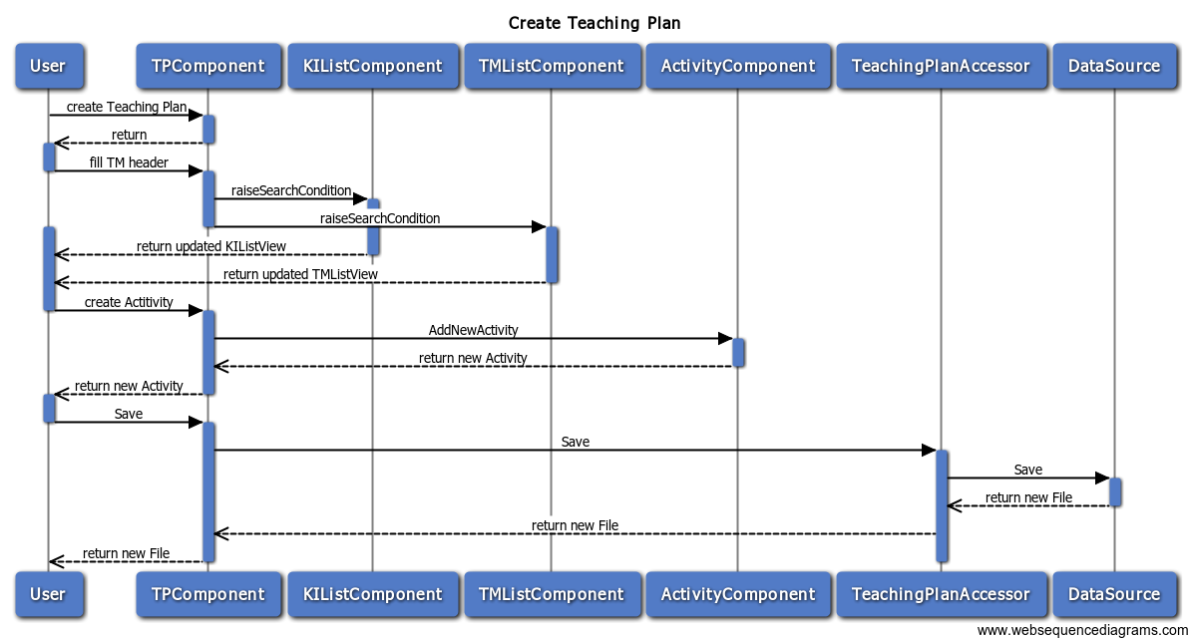

**Figure 7 - Create Teaching Plan Sequence Diagram**

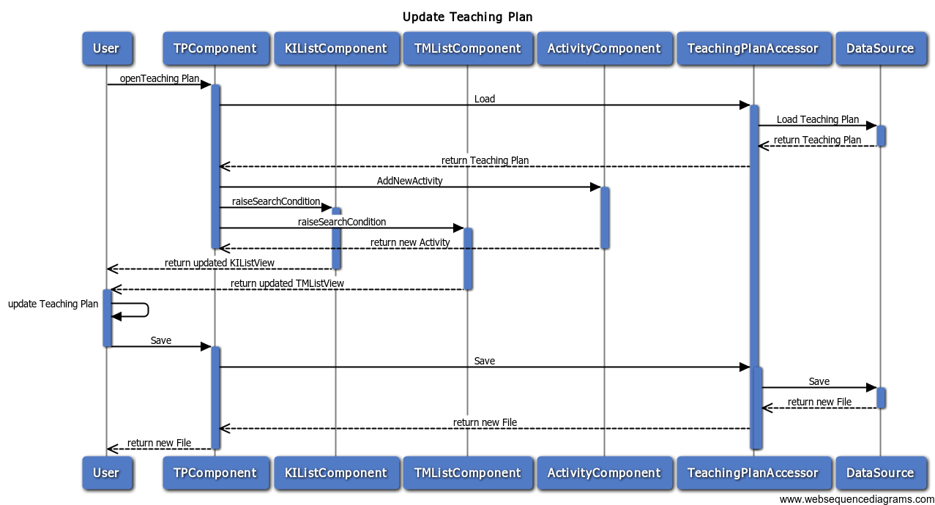

**Figure 8 – Update Teaching Plan Sequence Diagram**

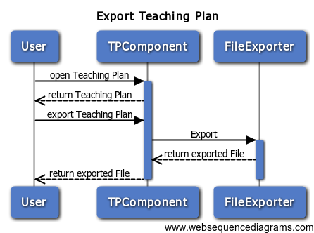

**Figure 9 - Export Teaching Plan Sequence Diagram**

* + 1. **Manage Knowledge Items**

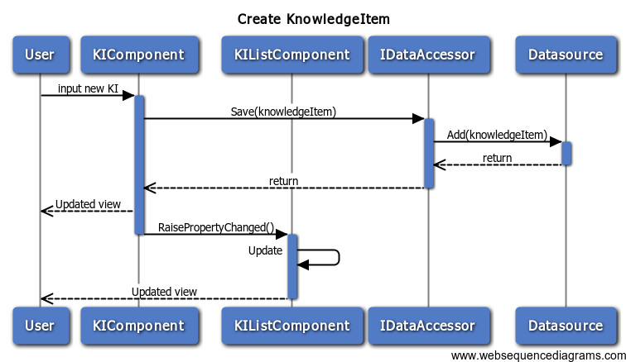

**Figure 10 - Create Knowledge Item Sequence Diagram**

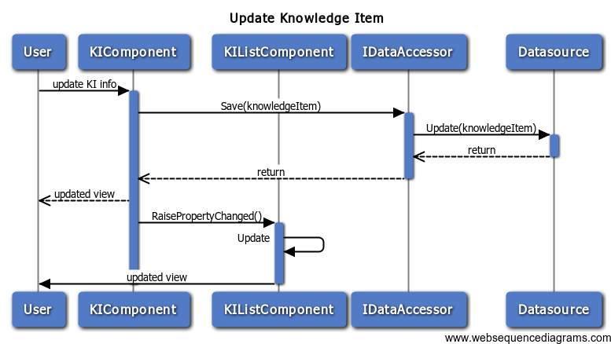

**Figure 11 - Update Knowledge Item**

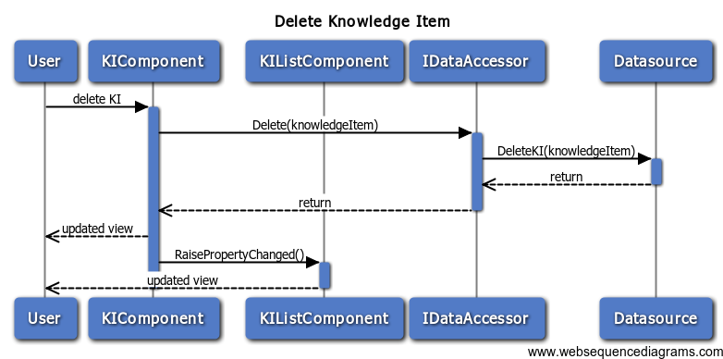

**Figure 12 - Delete Knowledge Item**

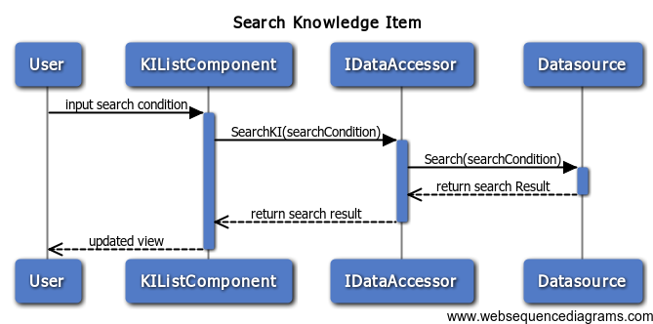

**Figure 13 - Search Knowledge Item**

* + 1. **Manage Teaching Methods**

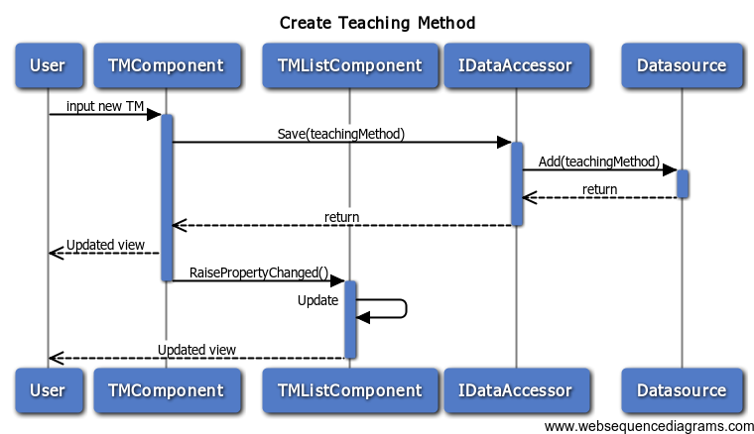

**Figure 14 - Create Teaching Method**

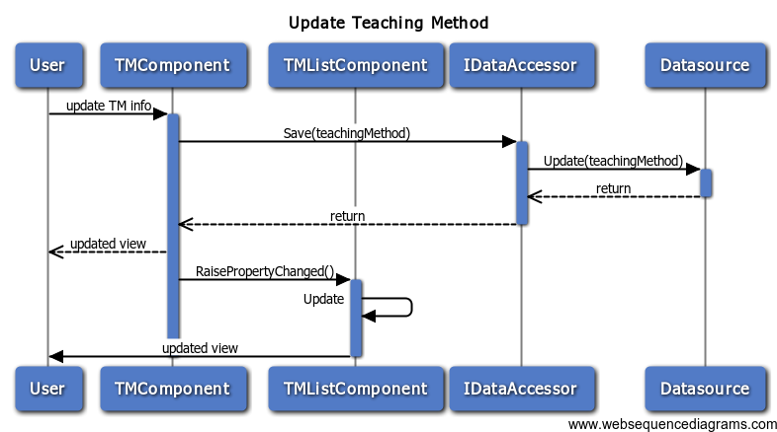

**Figure 15 - Update Teaching Method**

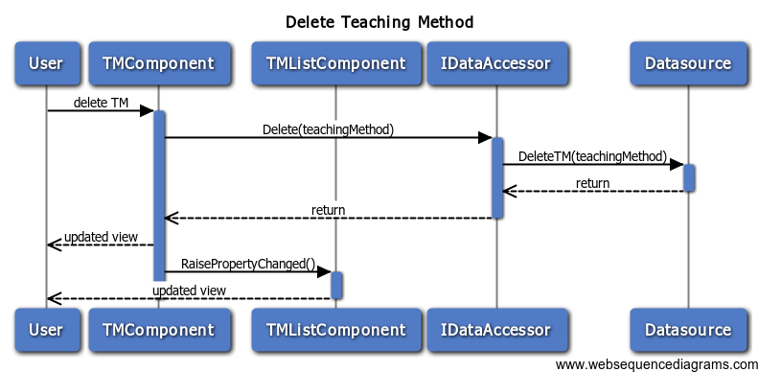

**Figure 16 - Delete Teaching Method**

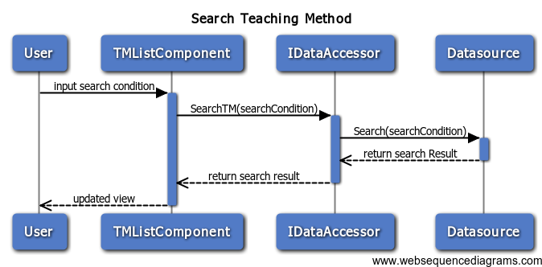

**Figure 17 - Search Teaching Method**

# User Interface Design

* 1. **Screen Flow**

|  |  |  |  |
| --- | --- | --- | --- |
| No | Screen ID | Screen Name | Reference |
| 1 | TLH\_SCR\_100 | Teaching Plan Compose Screen |  |
| 2 | TLH\_SCR\_200 | Knowledge Item Manage Screen |  |
| 3 | TLH\_SCR\_300 | Teaching Plan Manage Screen |  |
| 4 | TLH\_SCR\_400 | Help Screen |  |

**TLH\_SCR\_100**

Teaching Plan Compose Screen

**TLH\_SCR\_200**

Knowledge Item Manage Screen

**TLH\_SCR\_300**

Teaching Method Manage Screen

**TLH\_SCR\_400**

Help Screen.

Start

Select Tab

Select Tab

Select Tab

* 1. **Description of the User Interface**
     1. **TLH\_SCR\_100**

This is The Teaching Plan Compose Screen. This is also the main screen when the application starts.

* + - 1. ***Screen Images***

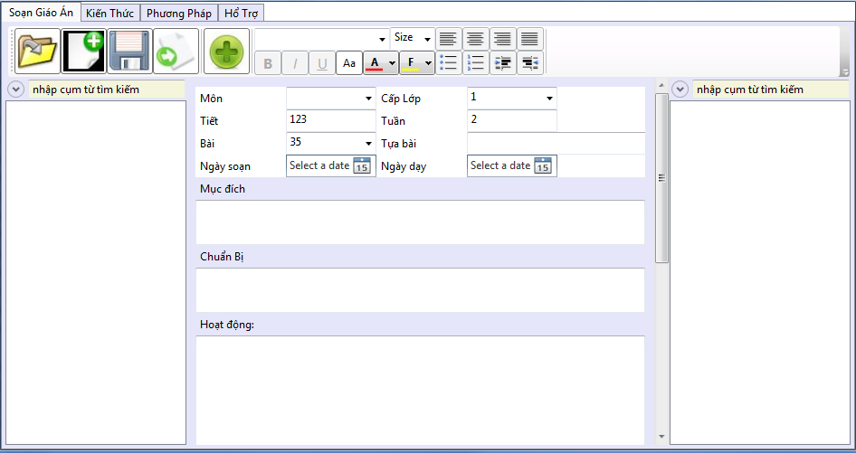

Figure 18 - Teaching plan Compose Screen

* + - 1. ***Objects and Actions***

|  |  |  |  |  |  |  |  |
| --- | --- | --- | --- | --- | --- | --- | --- |
| No | | Component Name | Component Type | Function | Format (Style) | Reference | Note |
| 1 | | Compose Teaching Plan tab | Tab Item | Contains all the controls and view of composing a Teaching Plan |  |  |  |
| 2 | Search KI panel | | Expander | Contains controls of searching Knowledge Item in need. |  |  |  |
| 3 | Search KI text box | | Text Box | Take key words inputted for searching KIs. |  |  |  |
| 4 | KI Class Level filter | | List Box | Take Class Level Condition for searching KIs. |  |  |  |
| 5 | KI Subject filter | | Combo Box | Take Subject Condition for searching KIs. |  |  |  |
| 6 | KI Topic Number Start filter | | List Box | Take Topic Number Start Condition for searching KIs. |  |  |  |
| 7 | KI Topic Number End filter | | List Box | Take Topic Number End Condition for searching KIs. |  |  |  |
| 8 | KI list | | List View | Display KIs for composing |  |  |  |
| 9 | Compose Teaching Plan toolbar | | Toolbar | Contains all the controls of composing a teaching Plan |  |  |  |
| 10 | New Teaching Plan button | | Button | Create a new Teaching Plan |  |  |  |
| 11 | Open Teaching Plan button | | Button | Open an existed Teaching Plan |  |  |  |
| 12 | Save Teaching Plan button | | Button | Save Teaching Method |  |  |  |
| 13 | Export Teaching Plan button | | Button | Export Teaching Plan to a specific File Type |  |  |  |
| 14 | Add Activity button | | Button | Add Activity to the composing Teaching Plan |  |  |  |
| 15 | Bold button | | Button | Format Text into Bold |  |  |  |
| 16 | Italic button | | Button | Format Text into Italic |  |  |  |
| 17 | Underline button | | Button | Format Text into Underline |  |  |  |
| 18 | Font combo box | | Combo Box | Format Font |  |  |  |
| 19 | Font Size combo box | | Combo Box | Change Font Size |  |  |  |
| 20 | Font Size Increase button | | Button | Increase Font Size |  |  |  |
| 21 | Font Size Decrease button | | Button | Decrease Font Size |  |  |  |
| 22 | Font Color button | | Button | Change Font Color |  |  |  |
| 23 | Text Fill Color button | | Button | Change Text Fill Color |  |  |  |
| 24 | Text Align Left button | | Button | Align Text to the Left |  |  |  |
| 25 | Text Align Right button | | Button | Align Text to the Right |  |  |  |
| 26 | Text Align Center button | | Button | Align Text at Center |  |  |  |
| 27 | Text Align Justify button | | Button | Align Text into Justify |  |  |  |
| 28 | Increase Indent button | | Button | Increase Indent |  |  |  |
| 29 | Decrease Indent button | | Button | Decrease Indent |  |  |  |
| 30 | Format Bullet button | | Button | Format Bullet |  |  |  |
| 31 | Format Numbering button | | Button | Format Numbering |  |  |  |
| 32 | Insert Table button | | Button | Insert Table |  |  |  |
| 33 | Insert Image button | | Button | Insert Image |  |  |  |
| 34 | Week Input | | Numeric List Box | Take Teaching Plan Week Number |  |  |  |
| 35 | Compose Date picker | | Date Time Picker | Take Compose Date of Teaching Plan |  |  |  |
| 36 | Teaching Date picker | | Date Time Picker | Take Teaching Date of Teaching Plan |  |  |  |
| 37 | TP Subject combo box | | Combo Box | Take TP Subject |  |  |  |
| 38 | TP Topic Number combo box | | Combo Box | Take TM Topic Number |  |  |  |
| 39 | TP Topic rich Text box | | Rich Text Box | Take TP Rich Text Box |  |  |  |
| 40 | TP Class combo box | | Combo Box | Take TP Class. |  |  |  |
| 41 | TP Session Number list | | Numeric List Box | Take TP Session Number |  |  |  |
| 42 | TP Objectives rich text box | | Rich Text Box | Take TP Objectives Information |  |  |  |
| 43 | TP Preparation rich text box | | Rich Text Box | Take TP Preparations Information |  |  |  |
| 44 | TP Activities rich text box | | Rich Text Box | Take TP Activities |  |  |  |
| 45 | TP Experience rich text box | | Rich Text Box | Take TP Experience Note |  |  |  |
| 46 | Search KI panel | | Expander | Contains controls of searching Teaching Method in need. |  |  |  |
| 47 | Search TM text box | | Text Box | Take key words inputted for searching TMs. |  |  |  |
| 48 | TM Team Size filter | | Combo Box | Take Team Size Condition for searching KIs. |  |  |  |
| 49 | TM Preferred Subjects filter | | Combo Box | Take Prefer Subject Condition for searching TMs. |  |  |  |
| 51 | TM Preferred Class Level filter | | Combo Box | Take Class Level Condition for searching TMs. |  |  |  |
| 52 | TM Tools filter | | Rich Text Box | Take Tools Condition for searching TMs. |  |  |  |
| 53 | TM list | | List Box | Display TMs for composing |  |  |  |

* + 1. **LH\_SCR\_200**

This is the Knowledge Item Manage Screen. The system shows this screen when user clicks on the Knowledge Item Mange tab on the screen TLH\_SCR\_100. User uses this screen to manage Knowledge Items.

* + - 1. ***Screen Images***

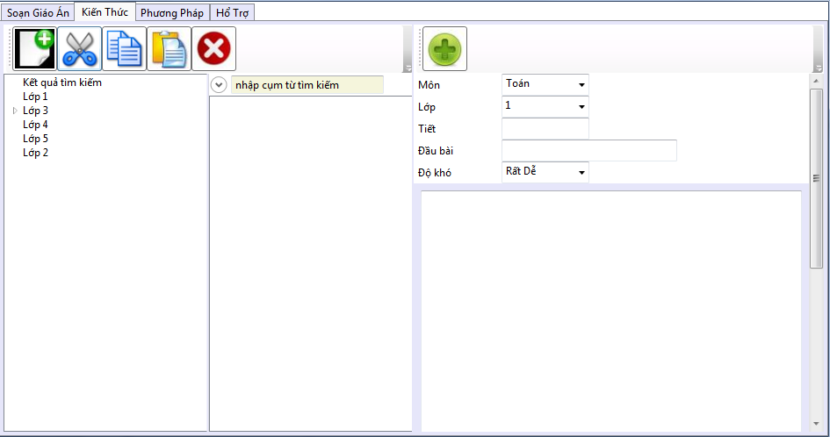

Figure 19 - Knowledge Item Management Screen

* + - 1. ***Objects and Actions***

|  |  |  |  |  |  |  |
| --- | --- | --- | --- | --- | --- | --- |
| **No** | **Component Name** | **Component Type** | **Function** | **Format (Style)** | **Reference** | **Note** |
| **1** | Manage KIs tab | Tab Item | Contains all the controls and view of managing a Knowledge Item. |  |  |  |
| **2** | Manage KIs toolbar | Toolbar | Contains all the controls of managing KIs. |  |  |  |
| **3** | New KI button | Button | Create a new KI. |  |  |  |
| **4** | Cut KI button | Button | Cut KI to move |  |  |  |
| **5** | Copy KI button | Button | Copy KI |  |  |  |
| **6** | Paste KI button | Button | Paste KI to current selected category. |  |  |  |
| **7** | Delete KI | Button | Delete selected KI. |  |  |  |
| **8** | KI category view | Tree view | List all categories of KIs. |  |  |  |
| **9** | Search KI panel | Expander | Contains controls of searching Knowledge Item in need. |  |  |  |
| **10** | Search KI text box | Text Box | Take key words inputted for searching KIs. |  |  |  |
| **11** | KI Class Level filter | List Box | Take Class Level Condition for searching KIs. |  |  |  |
| **12** | KI Subject filter | Combo Box | Take Subject Condition for searching KIs. |  |  |  |
| **13** | KI Topic Number Start filter | List Box | Take Topic Number Start Condition for searching KIs. |  |  |  |
| **14** | KI Topic Number End filter | List Box | Take Topic Number End Condition for searching KIs. |  |  |  |
| **15** | KI list | List View | Display KIs |  |  |  |
| **16** | KI Input toolbar | Toolbar | Contains all the controls of inputting KIs. |  |  |  |
| **17** | Bold button | Button | Format Text into Bold |  |  |  |
| **18** | Italic button | Button | Format Text into Italic |  |  |  |
| **19** | Underline button | Button | Format Text into Underline |  |  |  |
| **20** | Font combo box | Combo Box | Format Font |  |  |  |
| **21** | Font Size combo box | Combo Box | Change Font Size |  |  |  |
| **22** | Font Size Increase button | Button | Increase Font Size |  |  |  |
| **23** | Font Size Decrease button | Button | Decrease Font Size |  |  |  |
| **24** | Font Color button | Button | Change Font Color |  |  |  |
| **25** | Text Fill Color button | Button | Change Text Fill Color |  |  |  |
| **26** | Text Align Left button | Button | Align Text to the Left |  |  |  |
| **27** | Text Align Right button | Button | Align Text to the Right |  |  |  |
| **28** | Text Align Center button | Button | Align Text at Center |  |  |  |
| **29** | Text Align Justify button | Button | Align Text into Justify |  |  |  |
| **30** | Increase Indent button | Button | Increase Indent |  |  |  |
| **31** | Decrease Indent button | Button | Decrease Indent |  |  |  |
| **32** | Format Bullet button | Button | Format Bullet |  |  |  |
| **33** | Format Numbering button | Button | Format Numbering |  |  |  |
| **34** | Insert Table button | Button | Insert Table |  |  |  |
| **35** | Insert Image button | Button | Insert Image |  |  |  |
| **36** | KI Subject combo box | Combo Box | Take KI Subject |  |  |  |
| **37** | KI Class Level list | List Box | Take KI Class Level |  |  |  |
| **38** | KI Topic Number list | List Box | Take KI Topic Number |  |  |  |
| **39** | KI Topic rich text box | Rich Text Box | Take KI Topic |  |  |  |
| **40** | KI Content rich text box | Rich Text Box | Take KI Content |  |  |  |

* + 1. **TLH\_SCR\_300**

This is the Teaching Method Manage Screen. The system shows this screen when user clicks on the Teaching Method Mange tab on the screen TLH\_SCR\_100. User uses this screen to manage Teaching Methods.

* + - 1. ***Screen Images***

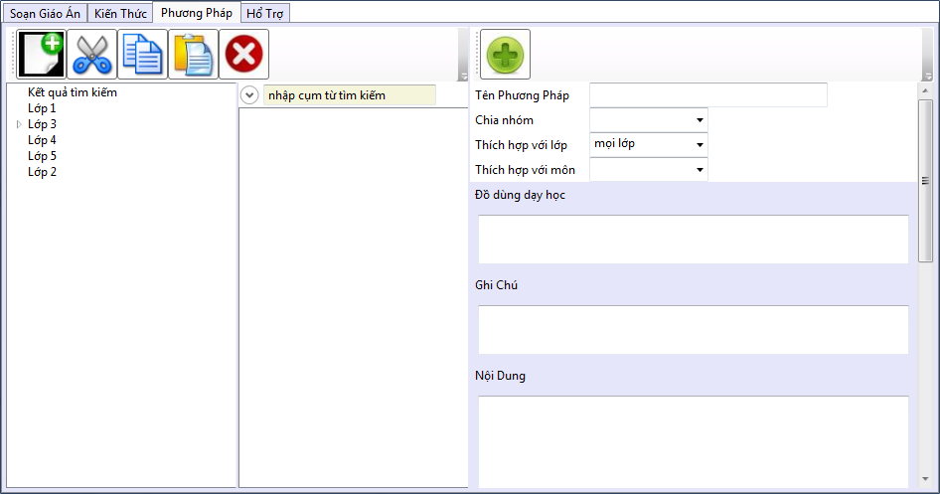

Figure 20 - Teaching Method Management Screen

* + - 1. ***Objects and Actions***

|  |  |  |  |  |  |  |
| --- | --- | --- | --- | --- | --- | --- |
| **No** | **Component Name** | **Component Type** | **Function** | **Format (Style)** | **Reference** | **Note** |
| **1** | Manage TMs tab | Tab Item | Contains all the controls and view of managing a Teaching Method. |  |  |  |
| **2** | Manage TMs toolbar | Toolbar | Contains all the controls of managing TMs. |  |  |  |
| **3** | New TM button | Button | Create a new TM. |  |  |  |
| **4** | Cut TM button | Button | Cut TM to move |  |  |  |
| **5** | Copy TM button | Button | Copy TM |  |  |  |
| **6** | Paste TM button | Button | Paste TM to current selected category. |  |  |  |
| **7** | Delete TM | Button | Delete selected TM. |  |  |  |
| **8** | TM category view | Tree view | List all categories of TMs. |  |  |  |
| **9** | Search TM panel | Expander | Contains controls of searching Teaching Method in need. |  |  |  |
| **10** | Search TM text box | Text Box | Take key words inputted for searching TMs. |  |  |  |
| **11** | TM Team Size filter | List Box | Take Team Size Condition for searching TMs. |  |  |  |
| **12** | TM Preferred Subject filter | List Box | Take Preferred Subject Condition for searching TMs. |  |  |  |
| **13** | TM Preferred Class filter | List Box | Take Preferred Class Condition for searching TMs. |  |  |  |
| **14** | TM Tools filter | Rich Text Box | Take key word of Tools for searching TMs. |  |  |  |
| **15** | TM List | List View | Display TMs |  |  |  |
| **16** | TM Input toolbar | Toolbar | Contains all the controls of inputting TMs. |  |  |  |
| **17** | Add TM Holder button | Button | Input TM Holder to TM Content. |  |  |  |
| **18** | Bold button | Button | Format Text into Bold |  |  |  |
| **19** | Italic button | Button | Format Text into Italic |  |  |  |
| **20** | Underline button | Button | Format Text into Underline |  |  |  |
| **21** | Font combo box | Combo Box | Format Font |  |  |  |
| **22** | Font Size combo box | Combo Box | Change Font Size |  |  |  |
| **23** | Font Size Increase button | Button | Increase Font Size |  |  |  |
| **24** | Font Size Decrease button | Button | Decrease Font Size |  |  |  |
| **25** | Font Color button | Button | Change Font Color |  |  |  |
| **26** | Text Fill Color button | Button | Change Text Fill Color |  |  |  |
| **27** | Text Align Left button | Button | Align Text to the Left |  |  |  |
| **28** | Text Align Right button | Button | Align Text to the Right |  |  |  |
| **29** | Text Align Center button | Button | Align Text at Center |  |  |  |
| **30** | Text Align Justify button | Button | Align Text into Justify |  |  |  |
| **31** | Increase Indent button | Button | Increase Indent |  |  |  |
| **32** | Decrease Indent button | Button | Decrease Indent |  |  |  |
| **33** | Format Bullet button | Button | Format Bullet |  |  |  |
| **34** | Format Numbering button | Button | Format Numbering |  |  |  |
| **35** | Insert Table button | Button | Insert Table |  |  |  |
| **36** | Insert Image button | Button | Insert Image |  |  |  |
| **37** | TM Name text box | Text Box | Take TM Name. |  |  |  |
| **38** | TM Team Size list box | List Box | Take TM Team Size. |  |  |  |
| **39** | TM Preferred Subject list box | List Box | Take TM Preferred Subject. |  |  |  |
| **40** | TM Preferred Class list box | List Box | Take TM Preferred Class. |  |  |  |
| **41** | TM Tools rich text box | Rich Text Box | Take TM Tools. |  |  |  |
| **42** | TM Note rich text box | Rich Text Box | Take TM Text Box. |  |  |  |
| **43** | TM Content rich text box | Rich Text Box | Take TM Content. |  |  |  |

* + 1. **TLH\_SCR\_400**

This is the Screen. The system shows this screen when user clicks on the screen TLH\_SCR\_. User uses this screen to.

* + - 1. ***Screen Images***

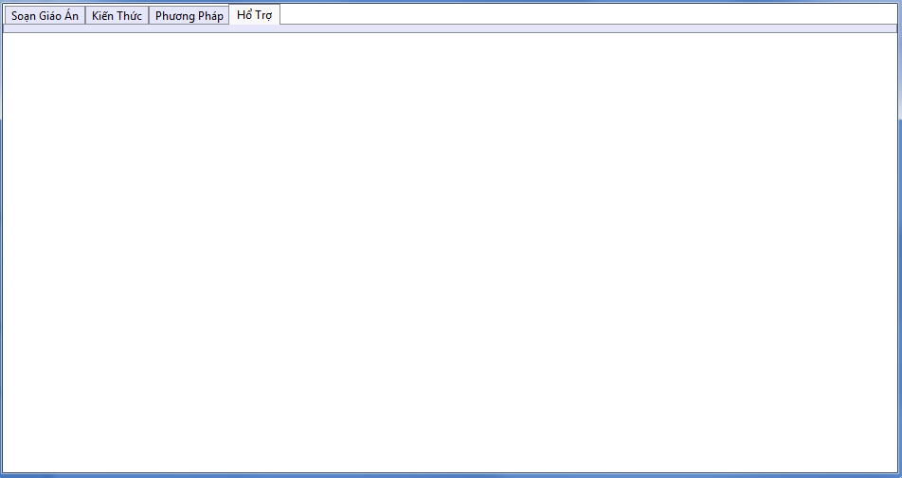

Figure 21- Help Screen

* + - 1. ***Objects and Actions***

|  |  |  |  |  |  |  |
| --- | --- | --- | --- | --- | --- | --- |
| **No** | **Component Name** | **Component Type** | **Function** | **Format (Style)** | **Reference** | **Note** |

# Database Design or Data Structures

This program do not use RDBMS(Relational Database Management System).

## Teaching Plan Structure

|  |
| --- |
| Figure 22 - Teaching Plan Data Structure |

|  |  |  |  |  |  |  |
| --- | --- | --- | --- | --- | --- | --- |
| No | Level | Element | Description | Cardinality | Facets | Attribute |
| 1 | 1 | TeachingPlan | The root element of XML document | Min: 1  Max: 1 |  |  |
| 2 | 1.1 | ComposingDate | The composing date of Teaching Plan | Min: 1  Max: 1 |  |  |
| 3 | 1.2 | TeachingDate | The date that teacher will teach with this Teaching Plan | Min:1  Max:1 |  |  |
| 4 | 1.3 | ClassLevel | The level of class ranges from 1 to 5 | Min:1  Max:1 |  |  |
| 5 | 1.4 | Subject | The subject, Math, Physics or Chemistry… | Min:1  Max:1 |  |  |
| 6 | 1.5 | Session | The slot of lesson greater than 0 | Min:1  Max:1 |  |  |
| 7 | 1.6 | Week | The week of lesson greater than 0 and less than 54 | Min:1  Max:1 |  |  |
| 8 | 1.7 | Topic | The topic of lesson, it has “Number” attribute which describe the number of topic, greater than 0 | Min:1  Max:1 |  | Number |
| 9 | 1.8 | Objective | The objective should be acquired through the lesson | Min: 1  Max: 1 |  |  |
| 10 | 1.9 | Preparation | The preparation for the lesson | Min: 1  Max: 1 |  |  |
| 11 | 1.10 | Activities | Activities element contains many sub-activity elements | Min:1  Max:1 |  |  |
| 12 | 1.10.1 | Activity | Activity is created from Knowledge Items and Teaching Methods | Min: 0  Max: unbounded |  | Name |
| 13 | 1.10.1.1 | Purpose | Describe the purpose of activity | Min: 1  Max: 1 |  |  |
| 14 | 1.10.1.2 | TeamSize | The number of pupils in a group. | Min: 1  Max: 1 |  |  |
| 15 | 1.10.1.3 | Content | The main content of activity, include Teaching Method and Knowledge Item | Min: 1  Max: 1 |  |  |
| 16 | 1.11 | ExperienceNote | Experience that the teacher make for teaching plan | Min: 1  Max: 1 |  |  |

## Knowledge Item Structure

|  |
| --- |
| Figure 23 - Knowledge Item Data Structure |

|  |  |  |  |  |  |  |
| --- | --- | --- | --- | --- | --- | --- |
| No | Level | Element/Attribute | Description | Cardinality | Facets | Attribute |
| 1 | 1 | KnowledgeItems | The root element of XML document, contains sub-KnowledgeItem elements | Min: 1  Max: 1 |  |  |
| 2 | 1.1 | KnowledgeItem | The KnowledgeItem element | Min: 0  Max: unbounded |  |  |
| 3 | 1.1.1 | ID | The ID of KnowledgeItem | Min:1  Max:1 |  |  |
| 4 | 1.1.2 | Class | The class level that Knowledge Items belong to, ranges from 1 to 5 | Min: 1  Max: 1 |  |  |
| 5 | 1.1.3 | Subject | The subject that Knowledge Items belong to: Math, Physics or Chemistry … | Min: 1  Max: 1 |  |  |
| 6 | 1.1.4 | Topic | The topic that the Knowledge Item belong to.It has the Number attribute | Min: 1  Max: 1 |  | Number |
| 7 | 1.1.5 | Content | The content of Knowledge Item. It has the Type attribute | Min: 1  Max: 1 |  | Type |

## Teaching Method Structure

|  |
| --- |
| Figure 24 - Teaching Method Data Structure |

|  |  |  |  |  |  |  |
| --- | --- | --- | --- | --- | --- | --- |
| No | Level | Element/Attribute | Description | Cardinality | Facets | Attribute |
| 1 | 1 | TeachingMethods | TeachingMethods element is the root of XML document, contains sub-TeachingMethod | Min:1  Max:1 |  |  |
| 2 | 1.1 | TeachingMethod | Teaching method contain 8 sub-elements | Min:0  Max:unbounded |  |  |
| 3 | 1.1.1 | Name | Name of teaching method | Min:1  Max:1 |  |  |
| 4 | 1.1.2 | TeamSize | Number of pupils in team | Min:1  Max:1 |  |  |
| 5 | 1.1.3 | Tools | Tools used for teaching method | Min:1  Max:1 |  |  |
| 6 | 1.1.4 | PreferredSubjects | This element contains sub-PreferredSubject elements | Min:1  Max:1 |  |  |
| 7 | 1.1.4.1 | PreferredSubject | This teaching method is suitable with subjects, Math, Physics or Chemistry… | Min:0  Max:unbounded |  |  |
| 8 | 1.1.5 | PreferredClassLevel | This method is suitable with class 1 or 2 … | Min:1  Max:1 |  |  |
| 9 | 1.1.6 | Content | Content of Teaching Method | Min:1  Max:1 |  |  |
| 10 | 1.1.7 | Note | Note for this method | Min:1  Max:1 |  |  |

# Index

[Figure 1-Application Architecture 5](#_Toc317720985)

[Figure 2 – MVP Architecture 7](#_Toc317720986)

[Figure 3 – System Component Diagram 8](#_Toc317720987)

[Figure 4 - Teaching Plan Class diagram 17](#_Toc317720988)

[Figure 5 - Knowledge Item Class Diagram 26](#_Toc317720989)

[Figure 6 - Teaching Method Class Diagram 35](#_Toc317720990)

[Figure 7 - Create Teaching Plan Sequence Diagram 49](#_Toc317720991)

[Figure 8 – Update Teaching Plan Sequence Diagram 50](#_Toc317720992)

[Figure 9 - Export Teaching Plan Sequence Diagram 50](#_Toc317720993)

[Figure 10 - Create Knowledge Item Sequence Diagram 51](#_Toc317720994)

[Figure 11 - Update Knowledge Item 51](#_Toc317720995)

[Figure 12 - Delete Knowledge Item 52](#_Toc317720996)

[Figure 13 - Search Knowledge Item 52](#_Toc317720997)

[Figure 14 - Create Teaching Method 53](#_Toc317720998)

[Figure 15 - Update Teaching Method 53](#_Toc317720999)

[Figure 16 - Delete Teaching Method 54](#_Toc317721000)

[Figure 17 - Search Teaching Method 54](#_Toc317721001)

[Figure 18 - Teaching plan Compose Screen 56](#_Toc317721002)

[Figure 19 - Knowledge Item Management Screen 60](#_Toc317721003)

[Figure 20 - Teaching Method Management Screen 63](#_Toc317721004)

[Figure 21- Help Screen 65](#_Toc317721005)

[Figure 22 - Teaching Plan Data Structure 66](#_Toc317721006)

[Figure 23 - Knowledge Item Data Structure 67](#_Toc317721007)

[Figure 24 - Teaching Method Data Structure 68](#_Toc317721008)